PSHCE - Good to be Me

Mixed Feelings
LESSON 2

Objectives
I can explain how I am feeling even if I have mixed feelings.

Activities
Read the short piece on mixed feelings from POWERPOINT.
Think about Dan’s feelings and why he might be feeling these things.
Consider the following scenarios (next slide) and think of the feelings you might have.
You are likely to have different feelings about the event to someone else in your family or friends and think about whether you could have both.

TASK
You need to identify pairs of feelings that can be linked together for the images.
Write a sentence to explain why the person might be feeling this way.

Outcomes
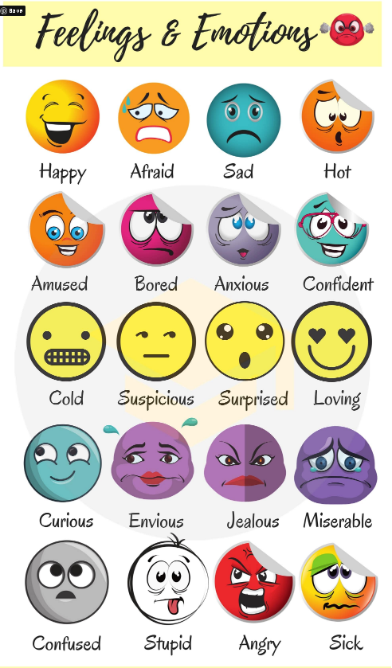
Children will consider when that have mixed feelings, what might bring on these feelings and how they can cope with them.

Notes
Good to be Me PowerPoint 2
TASK Sheet 2 (Mixed Feelings)

