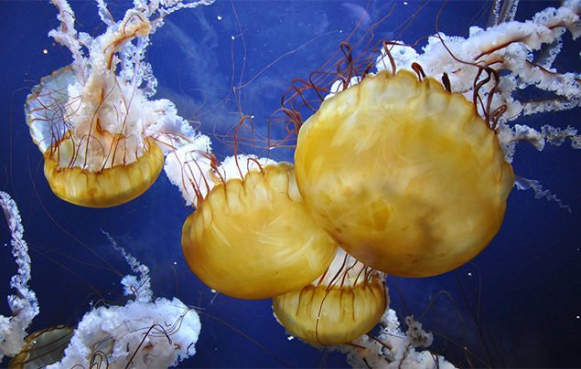 Jellyfish Information Text

Language features -
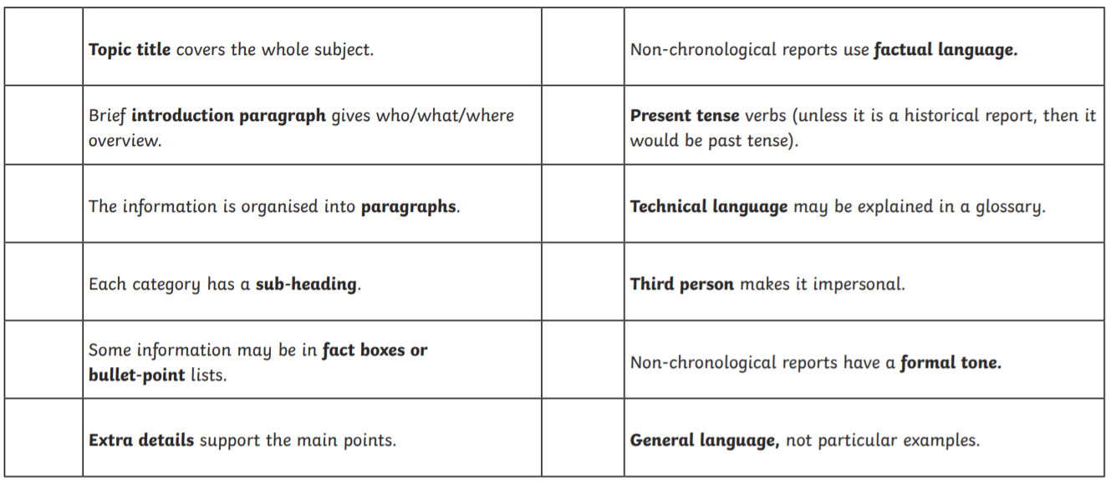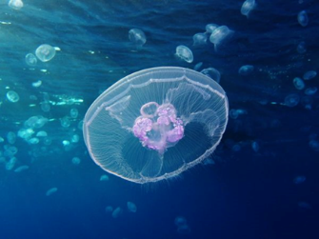
Paragraph ideas –
What are jellyfish? Are jellyfish fish?
Different species of Jellyfish.
Where do they live? How long do they live?
What do they look like?
How do they move?
What time of the day are jellyfish most active?
How do they feed? What do they eat?
Are jellyfish harmful to humans? How do they sting?
What is the deadliest jellyfish in the world?
What kills jellyfish?
The lifecycle of a jellyfish.
Interesting facts about jellyfish.

