IALT produce creative ideas around the idea of jellyfish ART
IALT create a collage

Jellyfish Collage

You will need:
- Glue
- Scissors
- Tracing paper
- String

Have a go at creating a jellyfish collage. Look at pictures of jellyfish and also watch (if you can) how they move in water.

Below is an idea of what to aim for.

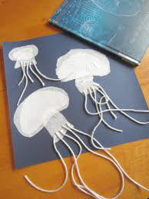

This is an example of previous children’s work.

