[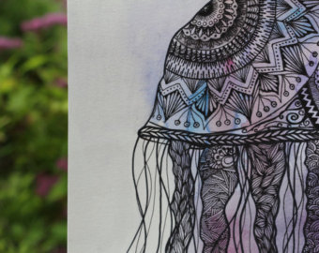](https://www.google.co.uk/url?sa=i&rct=j&q=&esrc=s&frm=1&source=images&cd=&cad=rja&uact=8&ved=0ahUKEwjrs--F6cLMAhVL2BoKHbH6AYsQjRwIBw&url=https://www.etsy.com/search?q%3Djelly%2Bfish%2Bart&psig=AFQjCNEGQ0tuV1rl921YzFPryLMe0CvhnA&ust=1462533762762049) [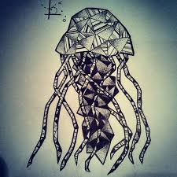](https://www.google.co.uk/imgres?imgurl=http://scontent-b.cdninstagram.com/hphotos-xfa1/t51.2885-15/10731752_664700466981222_2109771183_n.jpg&imgrefurl=http://jacksonvillexxxjaguars.blogspot.com/2014/10/jellyfish-oceanlife-geometry-geometric.html&docid=VL-0bmqP4YVq2M&tbnid=7ls_aKyyPXpB-M:&w=640&h=640&safe=strict&bih=799&biw=1365&ved=0ahUKEwiQytPw6cLMAhVI0hoKHQFwB24QMwhuKEcwRw&iact=mrc&uact=8)

[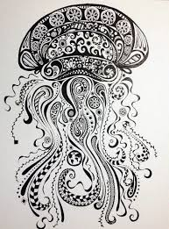](https://www.google.co.uk/imgres?imgurl=https://s-media-cache-ak0.pinimg.com/736x/ab/66/21/ab6621a08c766115dd81e177d0e1f8f5.jpg&imgrefurl=https://www.pinterest.com/pin/543176405029924089/&docid=Of7FVPSxPzs2IM&tbnid=5xnAOrnBjBET8M:&w=405&h=548&safe=strict&bih=799&biw=1365&ved=0ahUKEwiQytPw6cLMAhVI0hoKHQFwB24QMwhnKEAwQA&iact=mrc&uact=8) [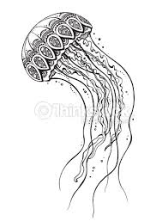](https://www.google.co.uk/imgres?imgurl=http://cache1.asset-cache.net/xc/495392796.jpg?v%3D2%26c%3DIWSAsset%26k%3D2%26d%3DK19L5neX6hn-UBt0XndJBz3Xk1uDXcum4tvFp_cbQbOuw1n4W3OVNDoGDhrsQ4rY0&imgrefurl=http://www.thinkstockphotos.co.uk/image/stock-illustration-hand-drawn-vector-jellyfish-in-black/495392796&docid=4KFpIKI98pPYLM&tbnid=qfDgVIs-eqK5OM:&w=363&h=475&safe=strict&bih=799&biw=1365&ved=0ahUKEwiQytPw6cLMAhVI0hoKHQFwB24QMwgkKAgwCA&iact=mrc&uact=8)[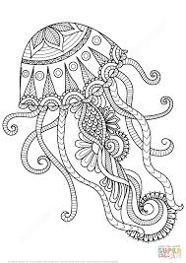](https://www.google.co.uk/imgres?imgurl=http://www.supercoloring.com/sites/default/files/styles/coloring_full/public/cif/2016/02/jellyfish-zentangle-coloring-page.png&imgrefurl=http://www.supercoloring.com/coloring-pages/jellyfish-zentangle&docid=zusXJTz7Y2KHVM&tbnid=LNFCLoNZ-pcWMM:&w=919&h=1300&safe=strict&bih=799&biw=1365&ved=0ahUKEwiQytPw6cLMAhVI0hoKHQFwB24QMwiIAShhMGE&iact=mrc&uact=8) [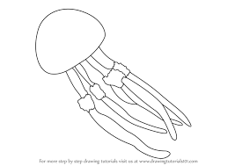](https://www.google.co.uk/imgres?imgurl=http://www.drawingtutorials101.com/drawing-tutorials/Animals/Fishes/jellyfish/how-to-draw-Jellyfish-step-0.png&imgrefurl=http://www.drawingtutorials101.com/how-to-draw-a-jellyfish&docid=reYZN6zbp4q-gM&tbnid=oOvQQwle62CTlM:&w=800&h=566&safe=strict&bih=799&biw=1365&ved=0ahUKEwjnwJP66cLMAhWFuRQKHZxUA8w4ZBAzCDUoMjAy&iact=mrc&uact=8) [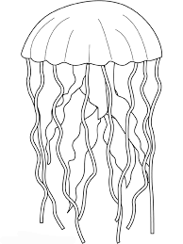](https://www.google.co.uk/imgres?imgurl=http://www.animalstown.com/animals/j/jellyfish/coloring-pages/jellyfish-color-page-5.gif&imgrefurl=http://www.animalstown.com/animals/j/jellyfish/coloring-pages/jellyfish-coloring-05.php&docid=Ck_O-SMPM6vVEM&tbnid=SUNWCWv0by4akM:&w=540&h=720&safe=strict&bih=799&biw=1365&ved=0ahUKEwjnwJP66cLMAhWFuRQKHZxUA8w4ZBAzCDMoMDAw&iact=mrc&uact=8)

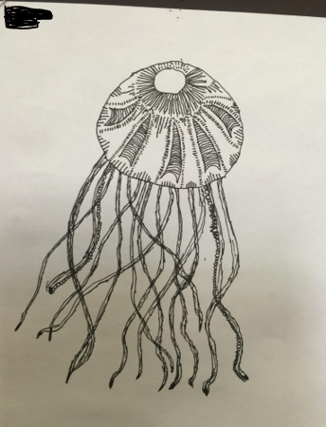WAGOLL – previous children’s examples

