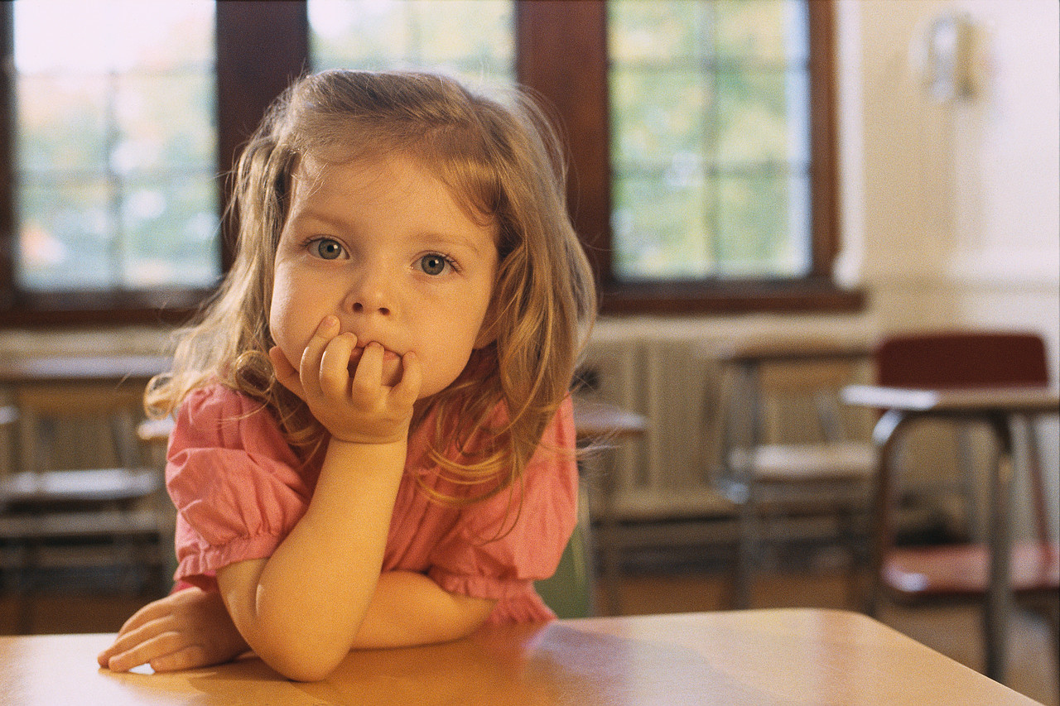
- “Who threw the glue stick out _________the window?” the teacher asked her class.



- “If you haven’t ___________ your PE kit to school today, then you won’t be able to take part in Sports day," said their teacher.


- “But I ____________ that Sports day was next week,” cried one little girl.


4.When Mum went to the supermarket, she kindly ____________ us some grapes as a special treat.

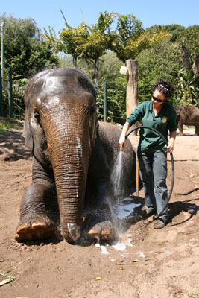
5.The elephant has such a ________, _________ skin that she needs to be scrubbed clean by her keepers.

