IALT mix paint in order to create a colour wash background
IALT use cutting skills to create a silhouette
- First, create a sunset colour wash for a back ground.
- Then cut a hole in a black piece of paper and a figure for Michael and Stella.
- Glue the silhouette to the colour wash once dry.

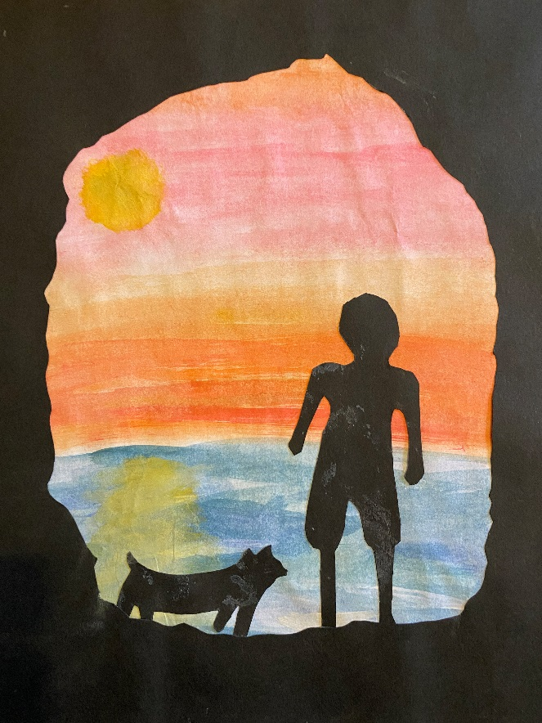
WAGOLLs
