[](https://www.google.co.uk/url?sa=i&rct=j&q=&esrc=s&source=images&cd=&cad=rja&uact=8&ved=0ahUKEwjKmPXP-tvMAhViCMAKHf55AGEQjRwIBw&url=https://www.pinterest.com/explore/cherry-blossom-art/&psig=AFQjCNHYfqHOKiOAzxfTPNaXVUMILFteAQ&ust=1463386327546377) [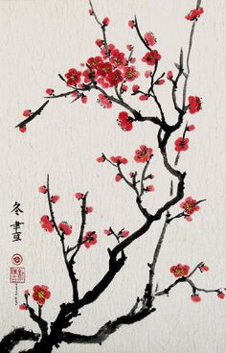](https://www.google.co.uk/url?sa=i&rct=j&q=&esrc=s&source=images&cd=&cad=rja&uact=8&ved=0ahUKEwj_vo_f-9vMAhXmJcAKHSCSCY8QjRwIBw&url=https://www.pinterest.com/explore/cherry-blossom-painting/&psig=AFQjCNHWow5FC3stWX3md3DcCNmTPyCIpw&ust=1463397786800555)

[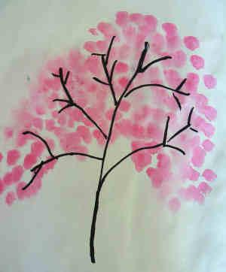](http://www.google.co.uk/url?sa=i&rct=j&q=&esrc=s&source=images&cd=&cad=rja&uact=8&ved=0ahUKEwjNn6f5-tvMAhVSFMAKHUp6DzEQjRwIBw&url=http://www.activityvillage.co.uk/japan-crafts&psig=AFQjCNHYfqHOKiOAzxfTPNaXVUMILFteAQ&ust=1463386327546377)[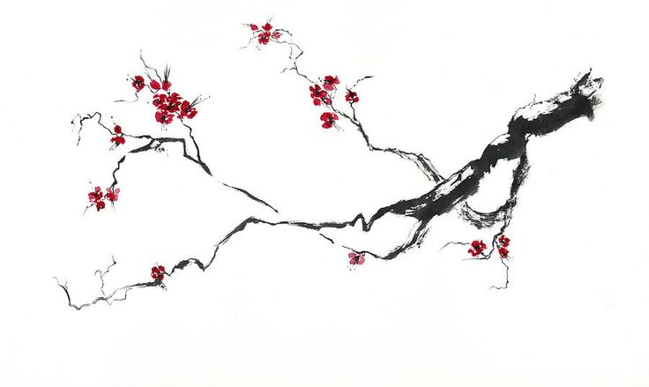](https://www.google.co.uk/url?sa=i&rct=j&q=&esrc=s&source=images&cd=&cad=rja&uact=8&ved=0ahUKEwjKmPXP-tvMAhViCMAKHf55AGEQjRwIBw&url=https://www.pinterest.com/pin/422564377509640715/&psig=AFQjCNHYfqHOKiOAzxfTPNaXVUMILFteAQ&ust=1463386327546377)

[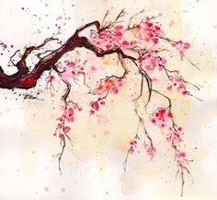](https://www.google.co.uk/url?sa=i&rct=j&q=&esrc=s&source=images&cd=&cad=rja&uact=8&ved=0ahUKEwjNn6f5-tvMAhVSFMAKHUp6DzEQjRwIBw&url=https://www.pinterest.com/explore/cherry-blossom-painting/&psig=AFQjCNHYfqHOKiOAzxfTPNaXVUMILFteAQ&ust=1463386327546377)

[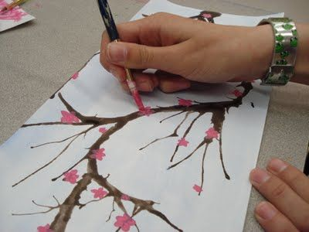](https://www.google.co.uk/url?sa=i&rct=j&q=&esrc=s&source=images&cd=&cad=rja&uact=8&ved=0ahUKEwjl7p_F-9vMAhVgGsAKHRIWAcQQjRwIBw&url=https://www.pinterest.com/pin/104005072614355292/&bvm=bv.122129774,d.d24&psig=AFQjCNF_hteZYCbQ9pjuKKyIrYoSjq2VPw&ust=1463397718416889)