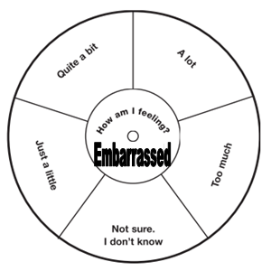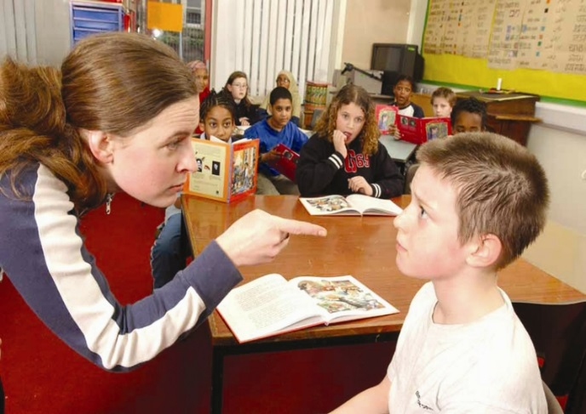

Lesson 2

IALT tell you about a time when I felt embarrassed and what it felt like.

IALT know some things to do when I feel embarrassed that will not make things worse.

Embarrassing...

Write about the reasons for you choices.

Relationships –Resource Sheet 2 –Blushometer