Learning Objective
We are learning how to use and punctuate direct speech.

Challenge 1
Someone has forgotten to put the inverted commas (speech marks) around the spoken words in the sentences below. Can you put them in the right places?

- I think a carmine bee-eater has just flown out of that hole in the riverbank, whispered the excited birdwatcher.
- That was delicous! said Bert, having just swallowed the locust whole.
- Don’t forget to remove the venomous stinger from that bee! shouted Bert in a concerned voice.
- Bert the bee-eater sighed, I’m really disappointed that we haven’t seen an elephant for almost three days.
- The bee-eater, who was hitching a ride on the back of an ostrich, shouted, I’ve got a great view from up here!
- It’s getting late, said the anxious producer, so I think we should return to our jeep before the lions wake up.

Challenge 2
Complete the passage below by writing the spoken words of Bert and Beatrix. Don’t forget to start your spoken words with a capital letter, finish with the correct ‘end’ punctuation mark and enclose them with inverted commas (speech marks).

Suddenly, an enormous bull elephant came into view. As the giant strode through the long grass, Bert said excitedly, ______________________________________________
Having discussed the risks involved, the bee eaters flew from their acacia tree perch and headed in the direction of the moving giant.
_________________________ said Beatrix anxiously. Bert assured Beatrix that the elephant was far too big to notice them. It wasn’t long before the two bee-eaters were darting around the elephant’s tree trunk-sized legs, picking off the grasshoppers that had been disturbed from the grass.
____________________________________________ shouted Bert as a gigantic tusk nearly knocked Beatrix out of the sky.
________________________________, replied Beatrix as she swooped beneath the lumbering giant’s body.
Challenge 3
Despite its enormous size, the bull elephant is getting irritated by Bert and Beatrix catching insects so close to him. He stops in his tracks and decides to have a stern word with them. Can Beatrix or Bert persuade the elephant to allow them to continue? What will they give him in return? Write this conversation using direct speech and some of the descriptive words from the Word Wall.
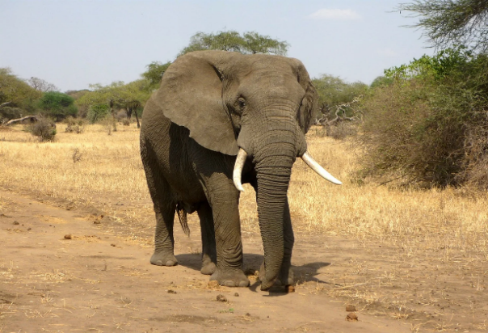
Word Wall

carmine bee-eater
flushed
risky
unnoticed
bull elephant
opportunity
irritated
aerial acrobatics
lush grass

