PSHCE: Lesson 3
IALT tell you about a time when I felt embarrassed and what it felt like.

IALT know some things to do when I feel embarrassed that will not make things worse

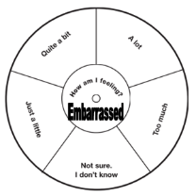
You copied your friend’s spelling test and your teacher has called you both up to speak to her. She is accusing you both of cheating.

Your school shoes break and you have to wear the ‘wrong’ sort of trainers to school.

You go to the toilet and a few minutes after you return to the classroom someone points out that you have a trail of toilet
paper stuck to your shoe.

Your teacher asks you to answer a question in maths. You don’t know the answer and make a wild guess – everybody laughs.

You fall over and although you are with your tough friends, you hurt yourself so badly that you can’t help the tears that come to your eyes. One boy shouts ‘Cry baby’.

You fall over as you are roller-blading by yourself – the tears come to your eyes, and a kind old lady asks you if you are OK.

You turn round in a shop to your friend saying, ‘Hey, you’d look great in those’, and realise that your friend has moved away and a total stranger is looking at you.

You are supposed to have gone to the mosque after school but some friends persuade you to go the park instead. A friend of your parents sees you and tells them.

You are caught taking a pound from your brother’s wallet (a) by your brother (who is always taking your stuff without asking) or (b) by your parents.

Relationships –Resource Sheet 3 –Situations

