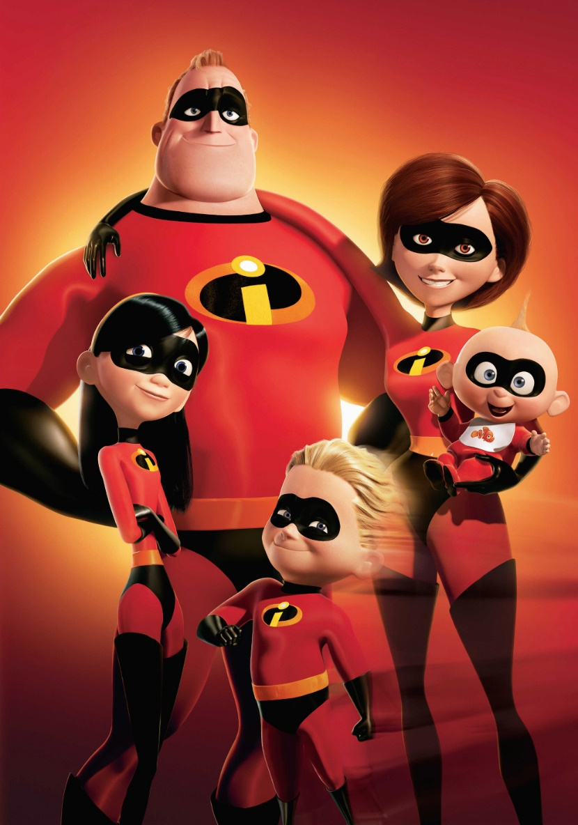

**Use this bank of vocabulary to help you:**

**Colours**

marron, gris, blonde, noirs, verts, bleus, roux

**Height**

Petite, grand, de taille moyenne

**Hair**

Boucles, longs, raides, brosse, courts, n’ai pas de cheveux

**Bob Parr**

**Jack-Jack Parr**

**Helen Parr**

**Dash Parr**

**Violet Parr**

**TASK:** Meet the Parr family – ‘The Incredibles’. Using the PowerPoint and bank of vocabulary, describe what 3 of the characters look like.