Relationships –Resource Sheet 4 –Situations II

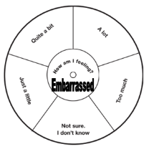

Embarrassing Situations II