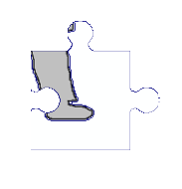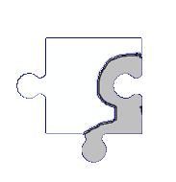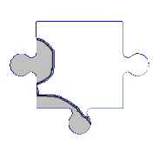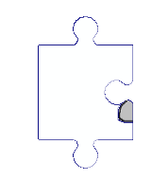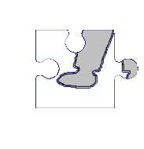Lesson 6

Relationships –Resource Sheet 6 –Jigsaw

Cut out the jigsaw pieces of the boy/ girl and arrange them on a sheet of paper, stick them with slight spaces. Write alongside about things that `Pick us up’

Relationships –Resource Sheet 6