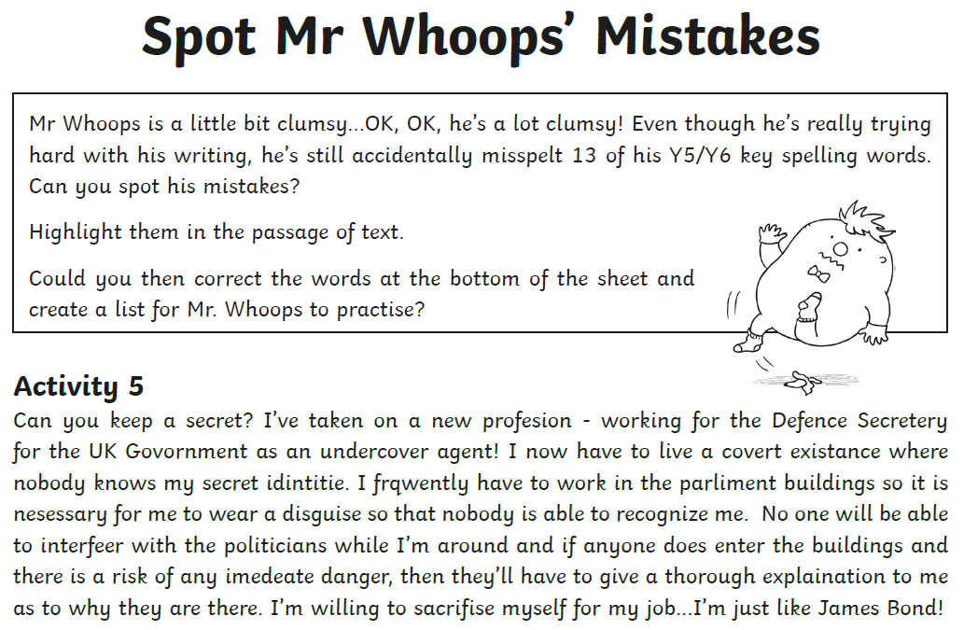

Mr Whoops needs to practise these spellings:
