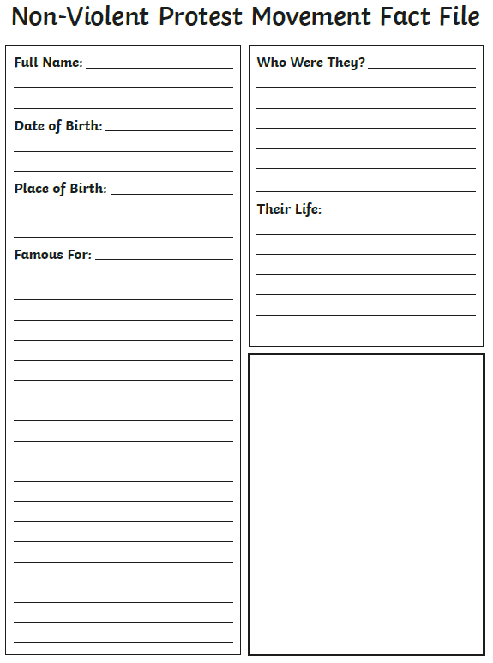

TASK: Research a key individual who has been part of a non-violent protest movement. What do you know about this key individual and what are their links to the non-violent protest.

To help you write the fact file, use either: Mahatma Gandhi, Nelson Mandela, Aung San Suu Kyi (from last week’s RE), John Hume or Martin Luther King information sheet.