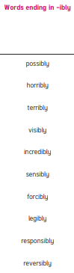

Year 5 & Year 6 Year 6

