highwaymen - noun
a man, typically on horseback, who help up travellers at gunpoint in order to rob them

torrent - noun
a strong moving stream of water
an overwhelming outpouring of (something, typically words)

gusty - adjective
blowing in gusts
having or showing gusto

galleon - noun
a sailing ship is use (especially Spain) from the 15th to the 18th centuries, originally in warship, later for trade.
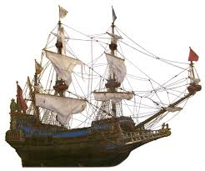
moor - noun
upland, typically covered with heather
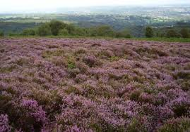
cocked - hat - noun
a brimless triangular hat pointed at the front, back and top
breeches - noun
short trousers fastened just below the knee, now chiefly worn for riding
claret - noun
- a red wine from Bordeaux
- a deep purplish-red colour
- blood (informal)

doe-skin - noun
leather made from skin of a doe fallow deer
tawny - adjective
of an orange-brown or yellowish-brown colour
rapier - noun
a thin, light sharp-pointed sword used for thrusting

hilt - noun
the handle of a weapon or tool, especially a sword, dagger, or knife
musket - noun
an infantryman's light gun with a long barrel, typically fired from the shoulder

wicket - noun
a small door or gate, especially one beside or in a larger one
cobble - noun
a small round stone used to cover road surfaces
casement - noun
a window or a part of a window set on a vertical hinge so that it opens like a door
ostler - noun
a man employed to look after the horses of people staying at an inn

harry - verb
persistently carry out attacks on (an enemy or an enemy's territory)
troop - noun
soldiers or armed forces
stirrup - noun
each of a pair of devices attached to each side of a horse's saddle, in the form of a loop with a flat base to support the rider's foot.
spurred - adjective
(of a rider or their boots) having a spiked device on the heels for urging a horse forward

ale - noun
any beer other than lager, stout or porter
priming - noun
a substance which primes something for use or action, in particular
- gunpowder placed in the plan of a firearm to ignite a charge

dawn - noun
the first appearance of light in the sky before sunrise

muzzle - noun
1.
- the projecting part of the face, including the nose and mouth of an animal such as a dog or horse
- a guard, typically made of straps or wire, fitted over an animal's muzzle to stop it biting or feeding
- the part of a person's face including the nose, mouth and chin (informal)

2.
- the open end of the barrel of a firearm

