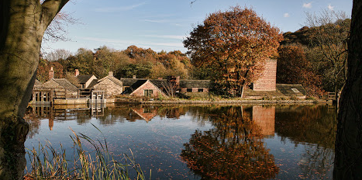
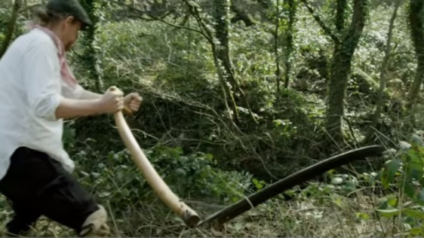
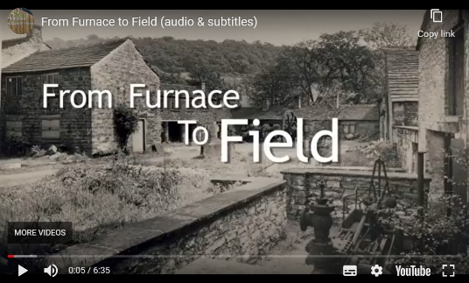
Abbeydale Industrial Hamlet

One of our main resources: From Furnace to Field

hamlet
dam wall
sluice gates
pond / dam
Using a scythe
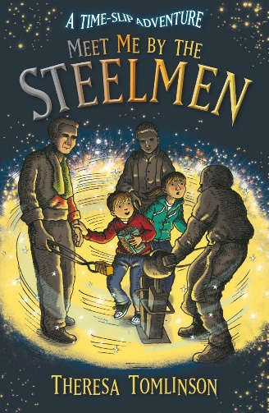
World Famous

a scythe
What is Abbeydale Industrial Hamlet?

Key Vocabulary
scythe | A bladed tool for cutting down grass or to harvest crops, before people had machines
industry | A business activity where a product is produced in factories, e.g. the steel industry
hamlet | A small collection of buildings / small village
raw materials | Materials, typically found in nature, such as wood, rock or metal before being processed into its final form / made into a product
steel | A strong, important metal, used for making thousands of things, from knives to buildings
crucible | A container / tall pot made of clay in which the materials for making crucible steel were heated to a very high temperature
crucible steel | A special steel of superior quality, made in crucible pots, in a furnace. Crucible steel was made of blister steel and iron, often with sand or glass, and heated until liquid, then cooled
water wheel | Water from the dam was poured over huge wooden wheels, causing them to rotate (turn around), driving the machinery in Abbeydale Works
furnace | A part of a building, made of brick or stone, where a fire can get hot enough to melt metal
forge | To make or shape something out of steel
River Sheaf | Fast flowing river which was dammed to create a source of power for the Works

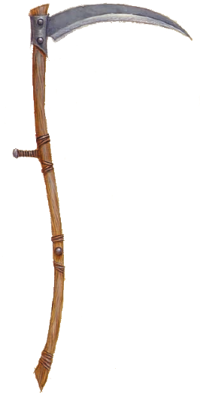
Abbeydale Works (now called Abbeydale Industrial Hamlet Museum) was once the largest water-powered industrial sites on the River Sheaf, in Sheffield. It has been a place of metal working for hundreds of years. From 1697 to 1933, scythes and other edge tools were made there. Almost all the processes needed to make scythes were carried out on site, from making the steel to grinding the blades.

At its peak in the 1850s, Abbeydale Works produced thousands of scythes a year. The tools were famous for their superior quality and craftmanship. They were exported as far away as Canada, India and Australia.

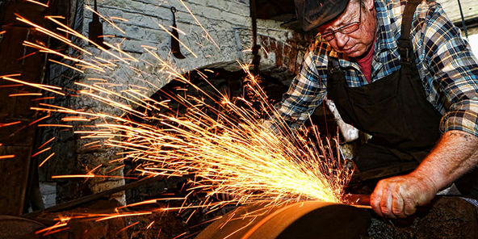
Grindstones

Grindstones were heavy wheels of sandstone, quarried in Heeley, Sheffield. Grindstones spun very quickly and helped sharpen blades.

Meet Me By The Steelmen is our class book. It is about two children who go back in time to help three steelmen whose job is was to make crucible steel.

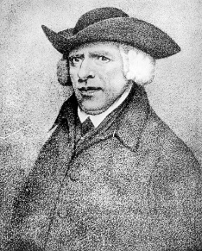
Famous Historical Figure

People had been making steel in Sheffield for many years, but Benjamin Huntsman invented a new way to make better quality steel, called crucible steel. He was so important that there are places in Sheffield named after him, such as ‘Huntsman Ward’ in the Northern General Hospital.

Working with grindstones was very hot, difficult, dangerous work. If you work really REALLY hard nowadays, it could be said that you have your ‘nose to the grindstone’!

