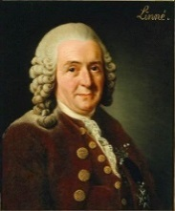[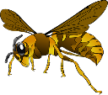](https://pixabay.com/en/hornet-wasp-insect-bee-brown-151003/)

**MRS GREN**

**M.R.S. G.R.E.N**. is a useful way to remember the necessary features of

living organisms.

**MOVEMENT**

It can change its position.

**RESPIRATION**

It releases energy from a food

source.

**SENSITIVITY**

It responds to things (e.g. light).

**GROWTH**

It can develop and get larger.

**REPRODUCTION**

It can make copies of itself or produce offspring.  
**EXCRETION**

It can get rid of waste products.

**NUTRITION**

It consumes chemical material / food.

Living Things and Their habitats

[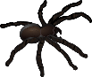](https://pixabay.com/en/animal-insect-short-abc-pictures-1300049/)[](https://pixabay.com/en/animals-reptiles-snake-1295060/)

[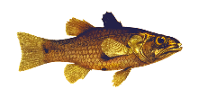](https://pixabay.com/en/animal-fish-ocean-sea-1300170/)[](https://pixabay.com/en/biodiversity-earthworm-fertilizer-160380/)

**Carl Linnaeus** simplified the naming of living things in 1735. Names of living things were often very long so he gave them a two-part (binomial) name. It was a mixture of genus and species (and in Latin) e.g. Human was Homo Sapien, Wolf was Canus Lupus and Lion was Felis Leo.

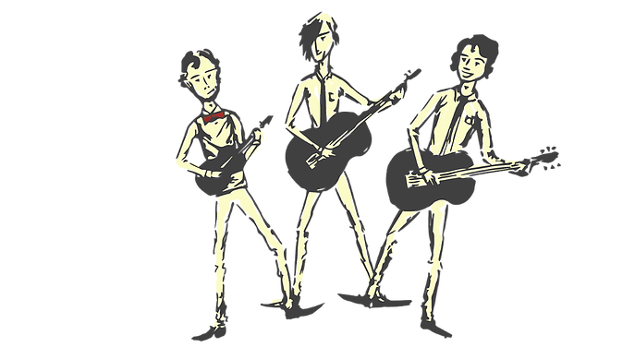

**Invertebrates** (no backbone)

In about 350 B.C. Aristotle (a Greek philosopher) classified all things into 4 main groups.

**Vertebrates** (backbone)

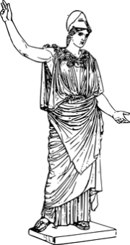[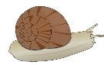](https://pixabay.com/en/snail-animal-slow-spiral-1293083/)[](https://pixabay.com/en/goldfinch-bird-yellow-golden-34663/)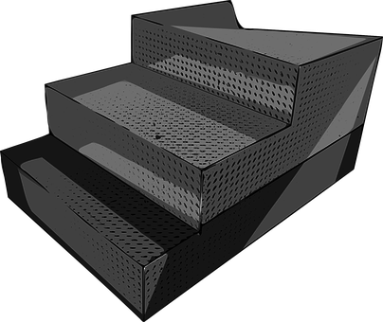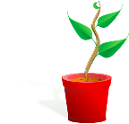[Image result for microorganism](https://www.google.co.uk/url?sa=i&rct=j&q=&esrc=s&frm=1&source=images&cd=&cad=rja&uact=8&ved=0ahUKEwjUxZnf2L3RAhXEnRoKHaFpCyoQjRwIBw&url=https://pixabay.com/en/biology-microbiology-microorganism-1295384/&bvm=bv.144210762,d.ZWM&psig=AFQjCNH1VekJlJS6DlQOknbrZL-U-05ZMQ&ust=1484347826226219)[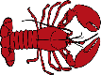](https://pixabay.com/en/lobster-animal-sea-food-ocean-red-311200/)[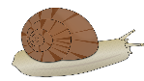](https://pixabay.com/en/snail-animal-slow-spiral-1293083/)[](https://pixabay.com/en/amphibian-animal-frog-nature-1295172/)[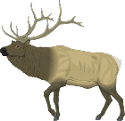](https://pixabay.com/en/moose-large-body-animal-mammal-48465/)[](https://pixabay.com/en/goldfinch-bird-yellow-golden-34663/)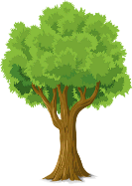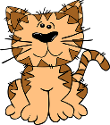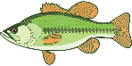

***Human Beings***

***Animals (cats and fish)***

***Plants (trees and grass)***

***Non-Living (rocks)***

**Groups of Living Organisms**

**Mammals -** warm-blooded, have hair on their bodies, parents care for the young, females produce milk for their babies, breathe through lungs, most are terrestrial (live on land) though some are aquatic (live in sea).

**Birds -** warm-blooded, most can fly, have feathers and wings, most build nests, hatch from eggs, most baby birds must be fed by parents and cared for until they can survive on their own (though some, like baby chickens and quail, can search for food a few hours after hatching)

**Fish -** aquatic animals, breath through gills, cold-blooded, most have scales, most develop from eggs that the female lays outside her body

**Amphibians -** live part of their life cycle in water and part on land, have gills when young, later develop lungs, cold-blooded, usually have moist skin.

**Reptiles** - hatch from eggs, cold-blooded, have dry, thick, scaly skin

Predators hunt and eat other animals. Prey are hunted by predators.

**Decomposer**

Feeds by decomposing the remains of living things.

**FOOD**

**CHAINS**

**Consumer**

Eats the producer. (Secondary consumers eat the primary consumer.)

**Producer**

Produced from an energy source (e.g. the sun) such as plants.

***Man-Made Threats to the Environment***

1.) Air pollution – Petrol and diesel used to power motor vehicles release carbon monoxide – a poisonous and harmful chemical. The burning of fossil fuels contribute to environmental damage too.

2.) Water pollution – Industrial waste and run-off from farming, which often uses fertilisers, can pollute rivers and streams.

3.) Rubbish –Plastic and household waste ends up on the streets, in the sea or in rubbish dumps, destroying habitats and wildlife.