Learning Objective
We are learning how to write sentences about orangutans that contain possessive apostrophes.

Challenge 1
Decide where the apostrophes should go in the following sentences:
- Orangutans are the worlds largest tree climbing mammals.
- An orangutans arms are both stronger and longer than its legs.
- The large males shaggy fur coats were very distinctive.
- The tigers huge appetite made the orangutan very nervous.
- As they swung through the treetops, the females fingers gripped tightly around the branches.
- The three males booming vocal calls echoed throughout the rainforest.
- Both of the females terrified infants were captured for the exotic pet trade.
- The orangutans nests were damaged in the storm.

Challenge 2
See if you can rewrite the following sentences so that they each contain a possessive apostrophe:

- The cheeks, which belonged to the large male orangutan, were the size of dinner plates.
- The leaves, which belonged to several lofty trees, were used by the orangutans to make umbrellas.
- The palm oil plantations, which belonged to the Indonesian and Malaysian Governments, destroyed the rainforest where the orangutans lived.
- Shelves, belonging to supermarkets around the world, are stocked with many products that contain palm oil.
- The nests, which belonged to several different families of orangutan, were damaged in the storm.

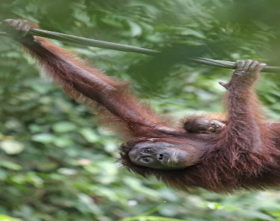
durian fruit
ripened
Sumatra
human-like
termites
poisonous
rainforest
educated
identified
prickly
raided
primate
probed
orangutan
Word Wall
Challenge 3
Take one of the sentences that you have written today and write 5 or 6 new sentences that follow on from it. Try to include some more sentences that require possessive apostrophes for both singular and plural nouns. See if you can include some of the descriptive words from the Word Wall.

