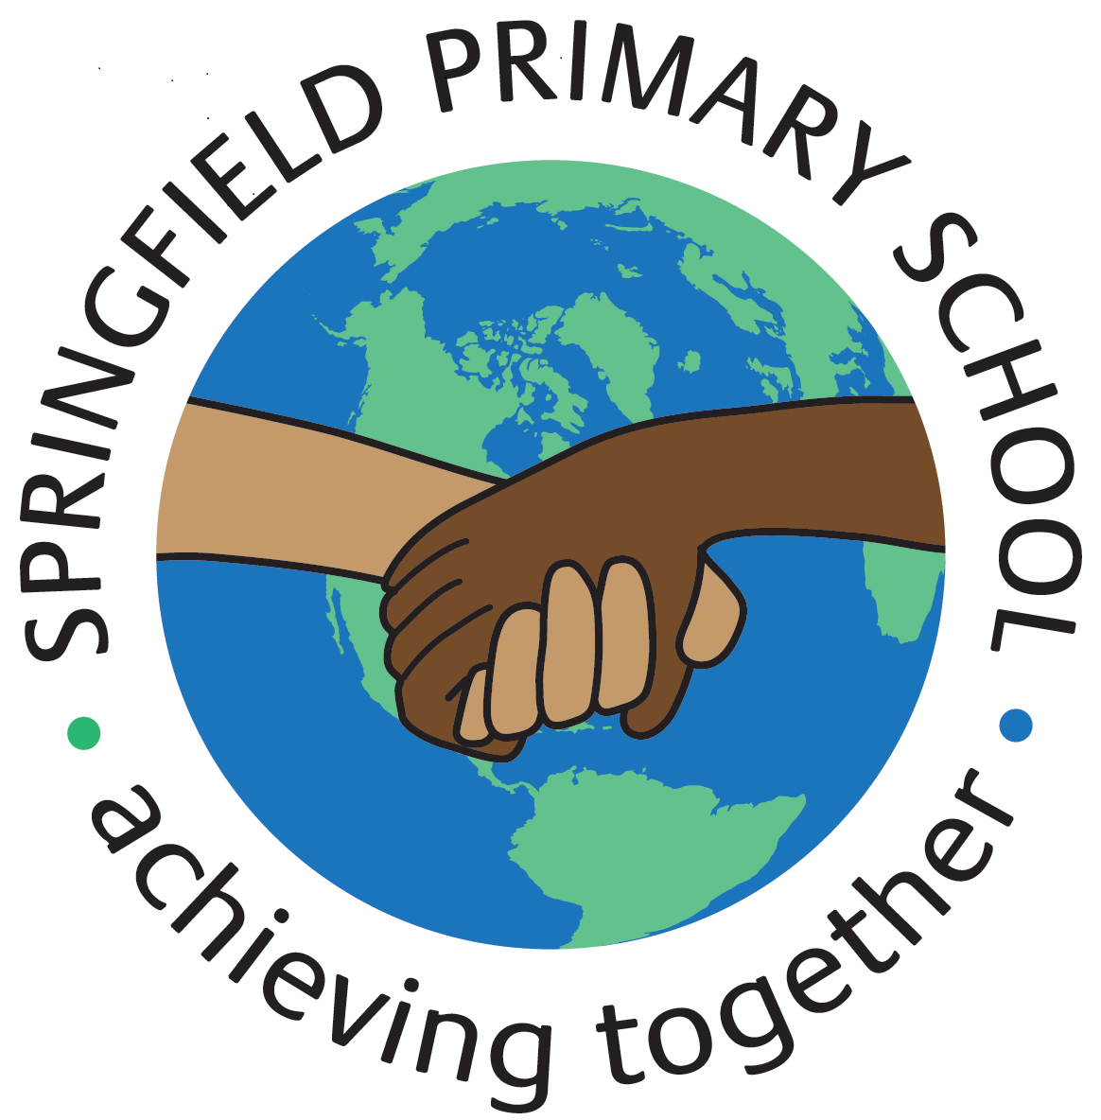
Half Term Curriculum Plan
Term: Autumn 2 2023 |  | Theme: Shake it up
Key Questions:  What is a volcano?  Where are volcanoes found?  How and why do volcanoes erupt?  What would you do in a disaster? |  | Stimulus: (Book/ Visit/ etc.)  Text:  Various non-fiction texts about volcanoes
As Writers we will:  Fiction:  *write an adventure story  Non-Fiction:  *write an explanation – How do animals adapt?  *write a non-chronological report – How are Volcanoes formed? |  | As Artists we will:  Not studied this Half Term | As Designers we will:  *explore how to reinforce a beam (structure) to improve its strength  *build a spaghetti truss bridge  *build and reinforce a wooden truss bridge  *evaluate our truss bridges | As Computer Engineers we will:  *discuss the different types of media used on websites  *recognise the common features of a web page  *why we should use copyright-free images  *evaluate what a web page looks like on different devices and suggest/make edits  *explain what a navigation path is and describe why it is useful  *create hyperlinks to link to other people's work
As Mathematicians we will:  *place equivalent fractions on a number line  *compare & order different fractions)  *add/subtract fractions including mixed numbers  *solve multi-step problems involving fractions  *multiply a fraction by a fraction/integer  *divide a fraction by an integer  *find a fraction of an amount  *understand and convert Metric measures  *calculate with metric measures  *understand miles & kilometres |  |  |  | As Musicians we will:  *identify the musical style of a song using some musical vocabulary to discuss its  Musical Elements
 |  | As French speakers we will:  *revise parts of the irregular verb ‘aller’  *learn how to form the simple future tense  *learn about where French is spoken in Africa  *learn about countries in West Africa  *revise parts of the verb ‘être’  *revise opinions, colours and clothes. |  | As Scientists we will:  *understand how offspring vary and are not identical to their parents  *learn about animal adaptations  *learn about plant adaptations  *explore what we can learn from fossils  *explore the theory of evolution by natural selection  *explore human evolution
As Geographers we will:  *understand how volcanoes affect the lives of people on Hiemaey | As Historians we will:  Not studied this Half Term | As Sportspeople we will:  *maintain possession when dribbling  *dribble with control under pressure  *select the appropriate skill, choosing when to pass and when to dribble  *move into and create space to support a teammate  *use the appropriate defensive technique for the situation  *apply rules, skills and principles to play in a football tournament  *develop an awareness of what our body is able to do  *develop speed and stamina, strength using our own body weight, coordination, agility and balancing with control |  | As learners of Religion we will:  *consider how stillness and silence help us to learn  *explore how breathing exercises help us to stay calm  *understand how a tensing exercise can lead us to better imagination  *understand what Sikhs think about the value of money  *understand what Muslims think about the beauty of nature  In RSHE we will:  *understand what stereotypes are  *learn to accept our friends for who they are  *explore what makes a family

