Y6 Springfield Primary School

Our curriculum drivers are evident throughout our planning and drive our curriculum.
1. Community and Real-Life Experience 2. Effective and Respectful Communicators 3. Achieving Success Together
Term: Summer1 |  | Theme: What is a river?
Key Questions:  - How does the course of the River Axe change from source to mouth?  - How does the course of my local river change from source to mouth?  - Why are river estuaries such important places for wildlife?  - Why are rivers such an important part of the water cycle?  - Why has Sheffield flooded in the past and what has been done to prevent it happening in the future? |  |  | Stimulus:  Floodland by Marcus Sedgwick 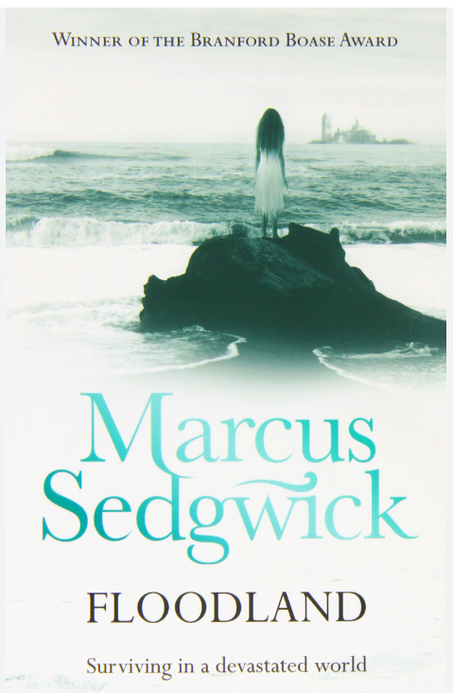
As Writers we will:  Develop our use of grammatical features including:  *punctuation of dialogue  *active and passive voice  *subordinate clauses  Fiction: write an adventure narrative to entertain  Poetry: write to entertain by creating a blackout |  | As mathematicians we will study:  Statistics:  *Read and interpret line graphs  *Read, interpret and draw pie charts  Shape:  *Measure and classify angles  *Calculate missing angles in triangles and quadrilaterals  *Study circles and their properties  *Draw 2D shapes accurately  *Look at the nets of 3D shapes | As computer engineers we will:  *Modify 3D objects  *Plan and create our own 3D model
As Designers we will:  *Design a steady hand game of our own according to our design criteria |  |  | As Geographers we will:  *Consider why rivers are so important  *Study two case studies of specific rivers  *Understand how the greatest mountain ranges were formed
As Artists we will:  Not studied this half term |  | As French speakers we will:  *Appreciate a story and understand the main points  *Perform a play to an audience  *Build phrases using je peux plus an infinitive | As musicians we will:  * Try out different ways of making our own music, while exploring the work of some of the most influential women in music over the last 100 years.
As Scientists we will:  *Describe the parts of an electric circuit  *Explore voltage and its effect on an electrical circuit  *Apply our knowledge to identify and correct problems in a circuit  * Investigate what affects the output of a circuit | As Historians we will:  Not studied this half term | As sportspeople we will:  Golf  *Develop our skills and apply them to striking, chipping, putting and playing a short and long game.  *Develop our coordination, accuracy and control of movements  *Understand the principles of golf and develop fluid movements that can be used in game situations  Netball  *Send and receive using a range of techniques with increasing control  *Dribble using a range of techniques with increasing control under pressure.  *Transition from attack to defence or defence to attack  *Confidently change direction to lose an opponent | As learners of religion we will:  *How do religions and beliefs respond to Global issues of human rights, fairness, social justice and the importance of the environment?  In RSHE we will:  Learn about Mental Well-being. We will learn how to understand our feelings.  * Does everyone have the same feelings?  * Should we be happy all the time?  * Why do we argue?

