Timeline
1333 | 1347 | 1348 | 1348 | 1349 | 1665 | 1666
The Black Death kills much of China’s population | The Black Death arrives in Europe via trading ships | The disease arrives in Weymouth, England and kills many, including the daughter of King Edward III. | By the Winter, it reaches London and kills up to 20,000 people (30-40% of the population). | King Edward III orders the streets to be cleaned of dead bodies. | The Great Plague of London | The Great Fire of London
 |  | Key Vocabulary
contagious | likely to spread to and affect others due to direct contact from one person to another
epidemic | widespread occurrence of an infectious disease in a community at a particular time.
quarantine | place of isolation in which people or animals that have been exposed to infectious or contagious diseases are put
pestilence | a fatal epidemic disease
pandemic | an outbreak of a disease over an entire country or across the whole world
bacteria | microorganisms which can cause diseases
bubonic | swollen inflamed lymph nodes in the armpit or groin
pneumonic | infection of the lungs where coughing spreads a disease by passing bacteria through the air
Plague Doctor | Plague doctors had masks with long beaks to keep herbs in (keep away bad smells), a stick to beat people away with, glass eye pieces and thick gowns.
Danse Macabre | people performed this dance to overcome a fear of death  DID YOU KNOW?
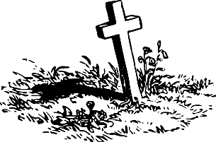
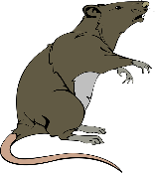
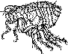
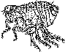
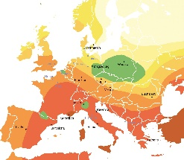
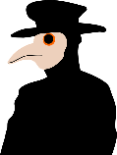
By 1350, the Black Death had run its course in England. There was no reason for its end other than it had simply run out of victims that it could claim. It wiped out between a third and half of the entire population.

Beginnings
During the 1200s, the Black Death originated from the Himalayan Mountains of South Asia where cramped conditions and close contact with rats created a breeding ground for the disease known as ‘Yersinia Pestis’. Rats then spread it to fleas which lived on them and drank their infected blood. It is these fleas which then bit humans passing it on.
The Spread of the Disease
Soldiers from Mongolia in Asia took the disease with them when they attacked the West in 1330 and by 1347 it had reached Turkey. As this was a major trading centre, merchants took it all the way through Europe. The Black Death spread from person-to-person through direct contact very easily. There had also been poor harvest in Europe around this time, making food less nourishing and therefore people found it harder to fight off illness.
Symptoms and Treatments
People would get headaches, fever, vomiting, lumps the size of oranges under the armpits and black boils and spots all over the body. From rubbing a live frog across a victim’s belly to drawing out poison using butter and onions, there were no treatments which actually worked, and most people died within three days.

Samuel Pepys (1633-1703)
A British Member of Parliament famous for his diary which provides an accurate picture of life in England in the 17th century. He started his diary in 1660, writing in it daily for almost 10 years, including historic events such as the Great Fire of London and the Plague. On 30th April 1665 he wrote: “Great fear of the sickness here in the City, it is being said that two or three houses are already shut up. God preserve us all.”
Michel de Nostredame (c. 1503-1566)
He travelled through France and Italy, treating victims of the plague. He recommended his patients drink only boiled water, sleep in clean beds and to leave infected towns as soon as possible and had good success rates. He also believed that he could predict the future and published his predictions in ‘The Prophecies’. People believe they have or will still come true.
Guy de Chauliac (1300-1368)
When the Black Death arrived in Avignon, France in 1348, doctors fled the city. However, Chauliac stayed on, treating plague patients and documenting symptoms. Chauliac distinguished between the two forms of the disease, the Bubonic Plague and the Pneumonic Plague.

Famous Figures
General Knowledge
The Black Death
Europe

