Reflecting Light
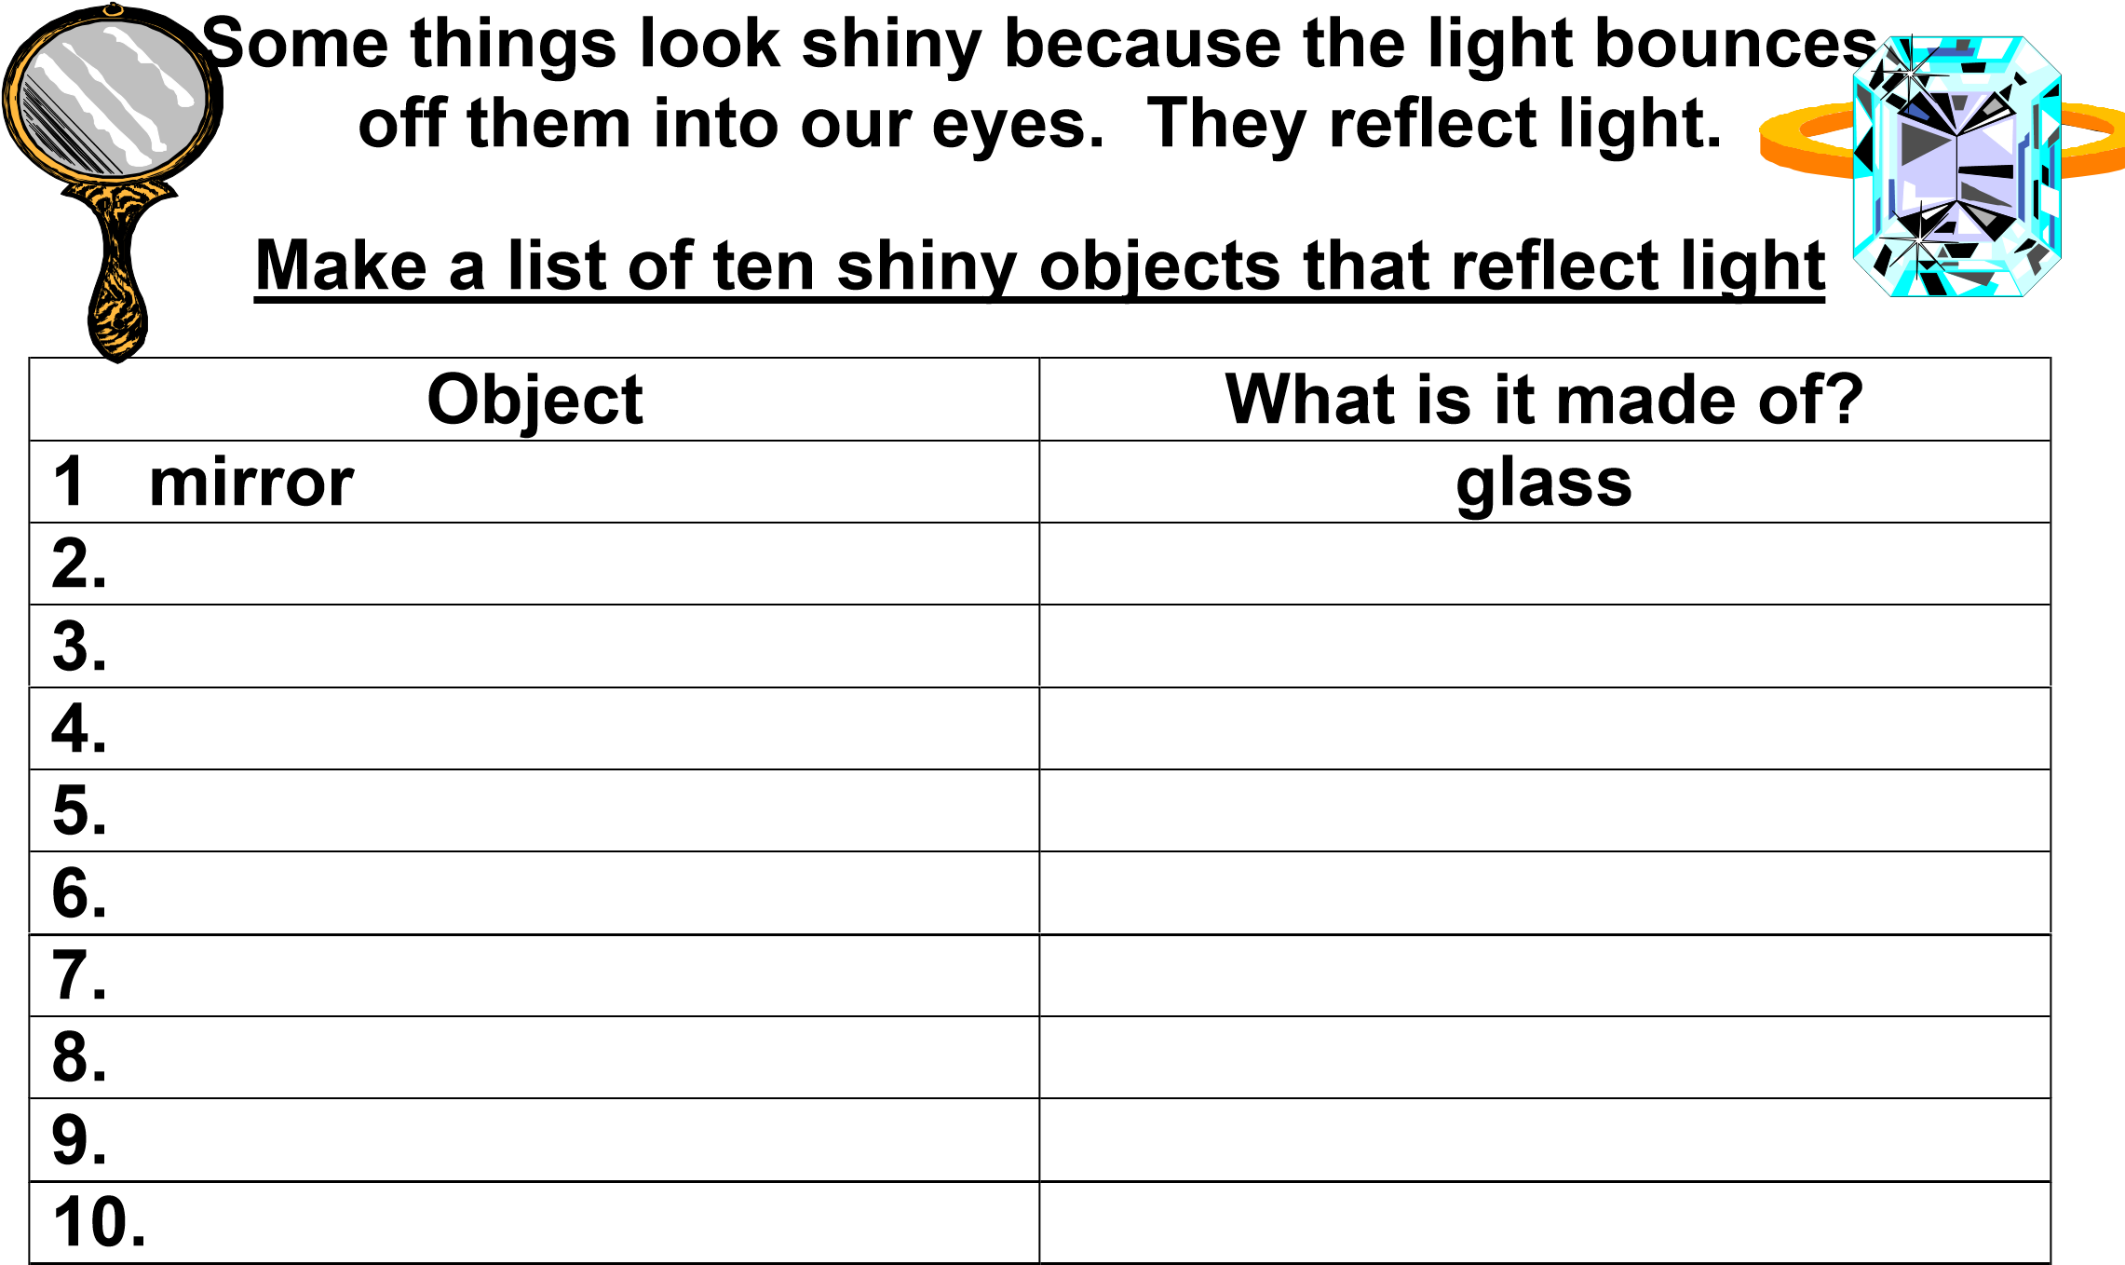
- Does the shape of the object make any difference to how shiny

it is?

- How could you make something more shiny?

- How could you make something less shiny?

- Try out your ideas on a piece of foil to see if they work

