Learn about one of the most famous palaeontologists ever.
https://www.bbc.co.uk/bitesize/topics/zd8fv9q/articles/zf6vb82

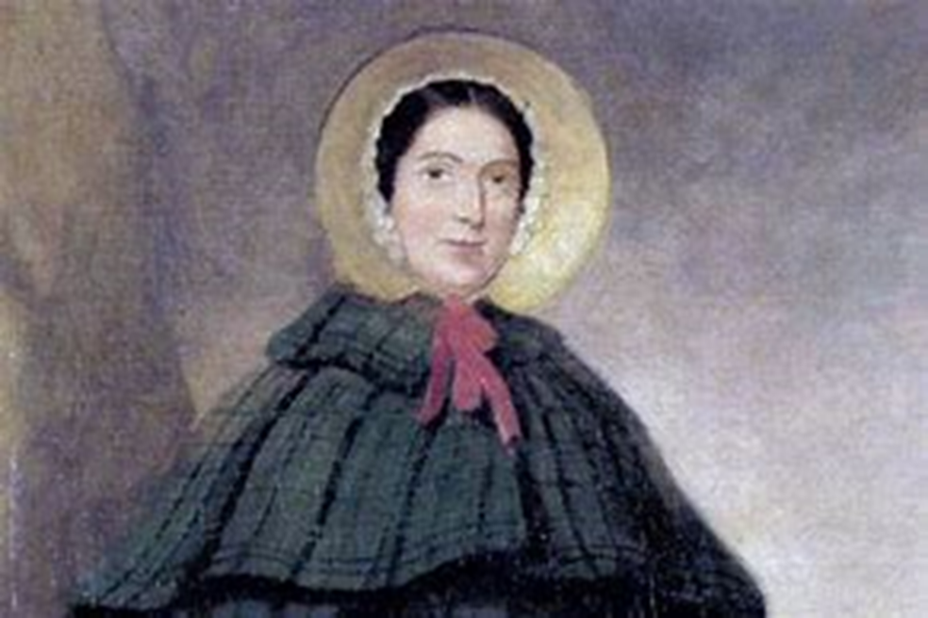

You can find more information about her on the Natural History Museum website.
https://www.nhm.ac.uk/discover/mary-anning-unsung-hero.html

