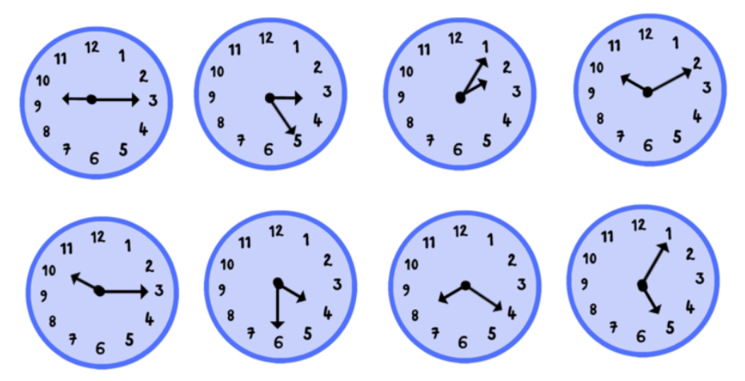

Don’t forget you can email us a photograph of your work to

[year5-6b@springfield.sheffield.sh.uk](mailto:year5-6b@springfield.sheffield.sh.uk)

We would love to see it! 😊

Can you write (in French!) the times shown on these clocks?