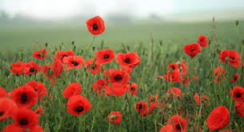
Remembrance Day

Can you research and find out the answers to these following questions?

- When is Remembrance Day?

- Why do we have Remembrance Day?

- Why do people wear poppies?

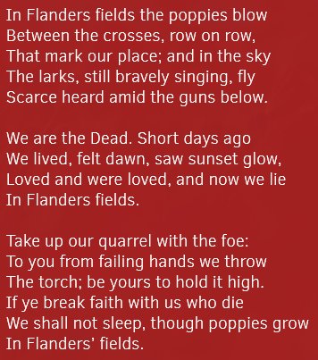
- Who wrote this poem? In Flanders Fields
What do you think of it?
What is effective about it?

Why not create your own poem or draw a poppy for Remembrance Day?
We would love to see what you think of this commemorative day!

