How are fossils made?

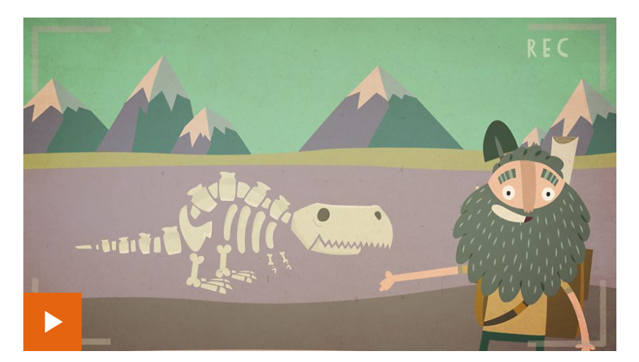

https://www.bbc.co.uk/bitesize/topics/z9bbkqt/articles/z2ym2p3

