IALT: explore and respond to ideas about creation from Islamic traditions
How does the Qu’ran talk about the beauty of the world?
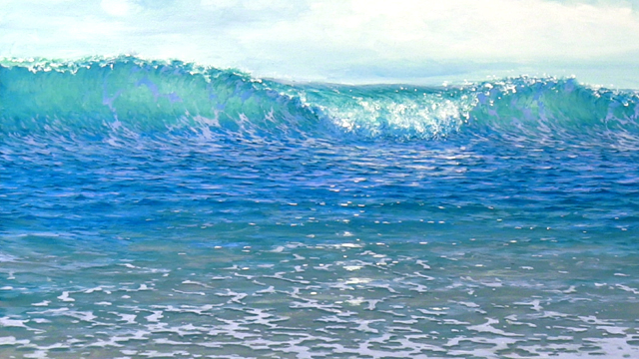
Water
The Qur’an talks about the contribution and importance of water in different contexts in the world.
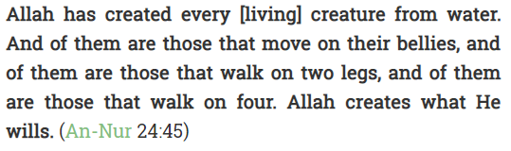
Water is among the most important ecosystem elements, it is mentioned in dozens of positions in the Qur’an.

Mountains
The mountains are among the important environmental elements mentioned in more than thirty positions in the Qur’an.
One of the functions of the mountains is that they can be used as a place for people to live inside them. Mountains contribute to the formation of clouds and rain. Therefore, the Qur’an linked in many verses between the mountains on one hand and rain, water and rivers on the other hand.
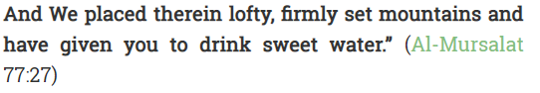
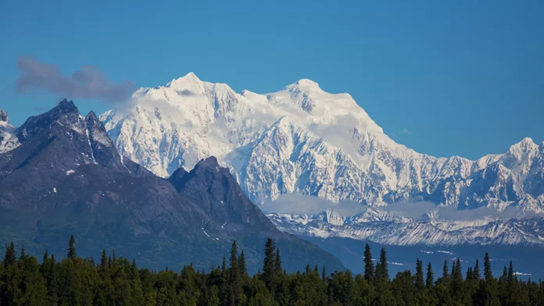
Animals
Animals are seen to have their own lives and purpose, valuable to themselves and to Allah. They are above and beyond any material value they may provide to humanity.
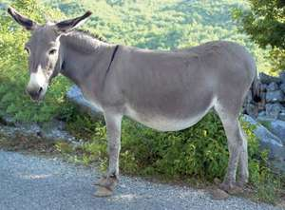
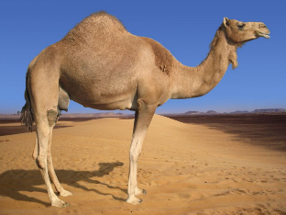
We should care for animals, especially camels and donkeys. They should not be expected to carry heavy loads in harsh environmental conditions and be left to drink as much water as they need.

Task:
From what you have read, can you share your opinion of the world?
- What are your thoughts on caring for these creations in the world?
- Why do we need to care for the world?

