IALT describe the most beautiful aspects of nature and respond to ideas about the creation
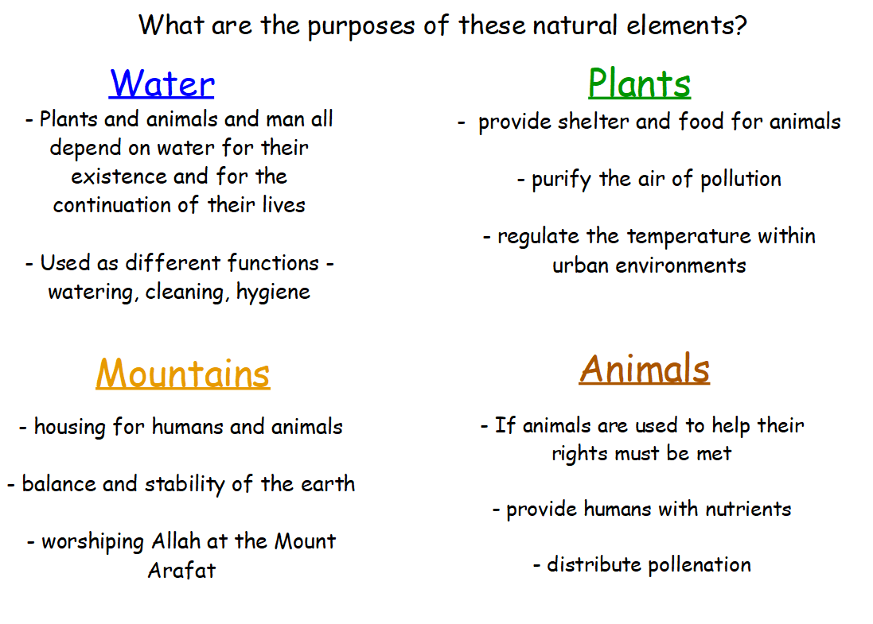

- Choose one photo and write a small paragraph to describe the beauty of nature in the picture
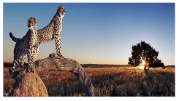
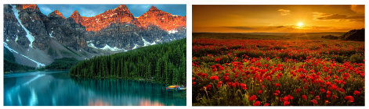

Why is this scene beautiful to you? Why was each natural element created?
Use your five senses, as if you was there. How does the nature make you feel?

E.g. The bright sunset is beaming with warmth while the rustling of the trees produce a calming sensation. In the distance, the towering trees provide animals with a home.
The rich, red poppies create food for insects and provides us with oxygen for a clearer and cleaner air.

2. Draw your own image that represents the beauty of nature

