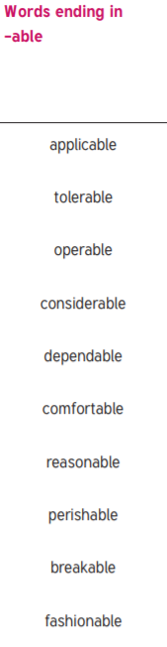
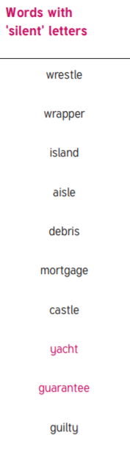
Y5 and Y6 Spellings Year 6 Spellings

