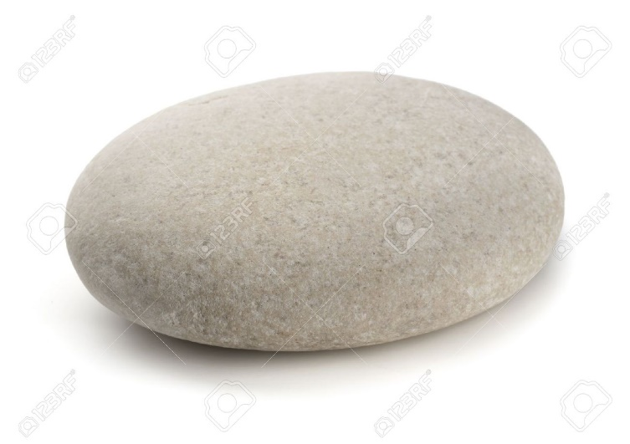
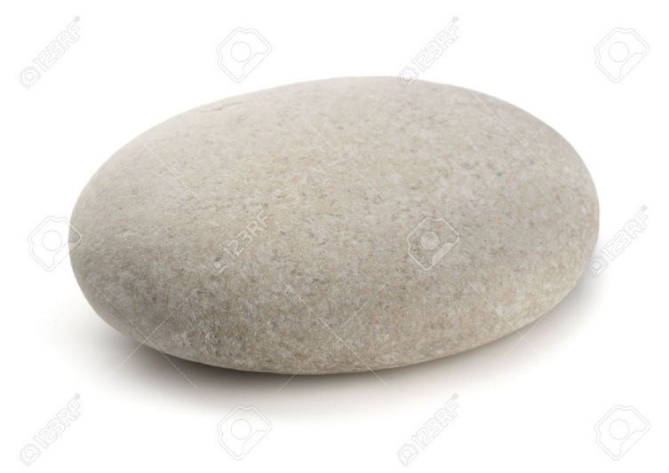
Name:
Week 2 w/c 11.01.21
Write the skills on or underneath the pebbles below.
Start with the most important to the least important.
There is no right or wrong answer.

