Draw and label the boat.

Simpler diagram of a boat.

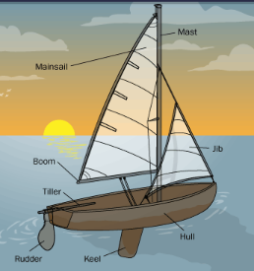

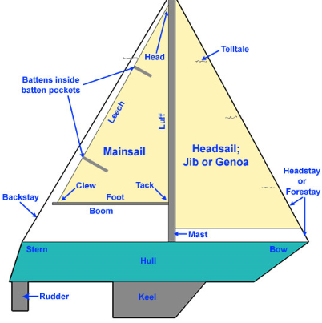

More challenging diagram of a boat.