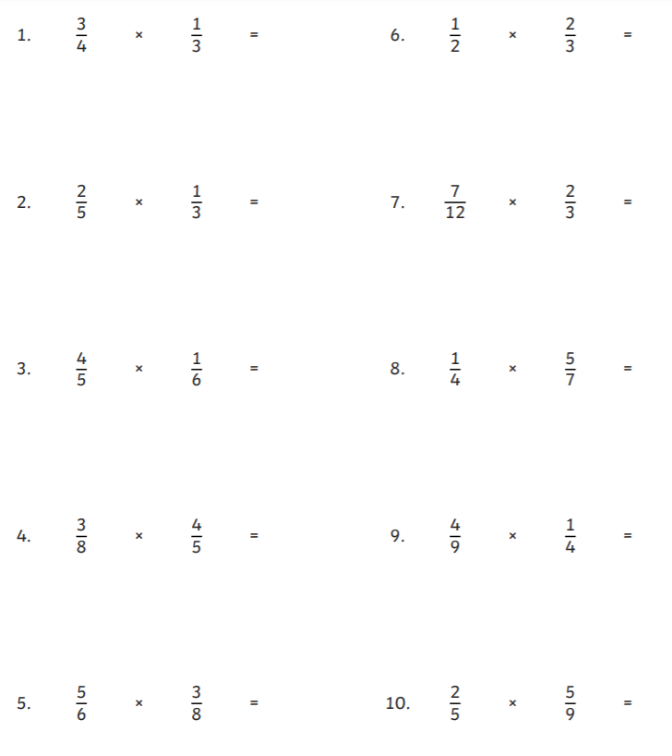
Multiplying fractions by fractions
Give your answer in the simplest form

