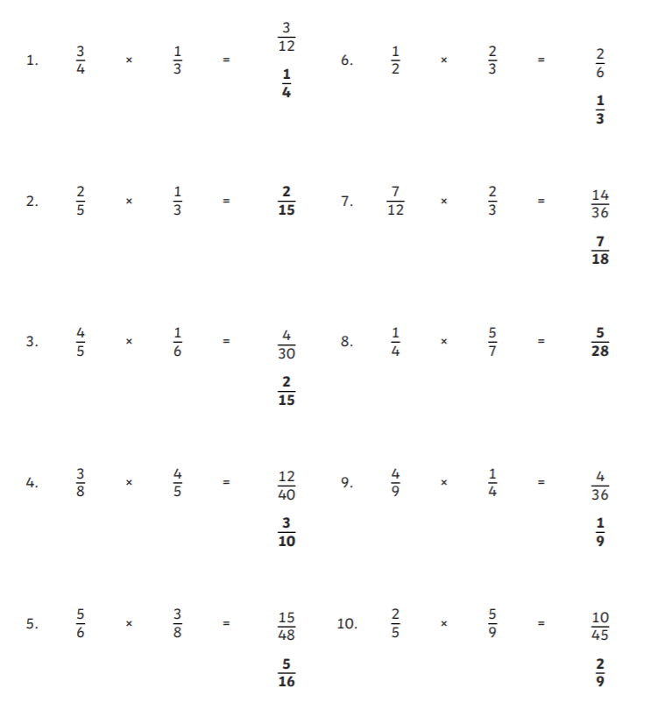
Multiplying fractions by fractions ANSWERS

