Miss Chan’s

- What is 1000 more than 2560?
- Order these numbers from smallest to largest: 4805, 4505, 4250, 4845, 4307
- Write the place value of the red digit: 6936
- Round 786 to the nearest ten
- What is 1000 less than 7870?
- 387 + 275 =
- 4,654 – 3,263 =
- Round 4345 to the nearest thousand
- 6 x 9 =
- 4,589 + 746 =
- 7² + 64 ÷ 8 =
- 27 x 4 =
- 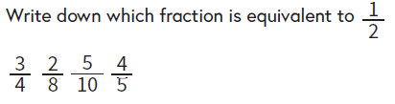
- 3 x 6 x 8 =
- 12 ÷ 1000 =
- 119 ÷ 7 =
- 2 + 3 =
- 236 x 5 =
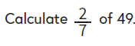
- Round 2.3 to the nearest whole number

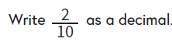
- 27 ÷ 10 =

- 2.6 x 100 =

