Miss Chan’s

1. What is 1000 more than 2560? 3560
2. Order these numbers from smallest to largest:4250, 4307,4505,4805, 4845
3. Write the place value of the red digit: 6936 900
4. Round 786 to the nearest ten 790
5. What is 1000 less than 7870? 6870
6. 387 + 275 = 662
7. 4,654 – 3,263 = 1391
8. Round 4345 to the nearest thousand 4000
9. 6 x 9 = 54
10. 4,589 + 746 = 5335
11. 72 + 64 ÷ 8 = 57
12. 27 x 4 = 108
13. 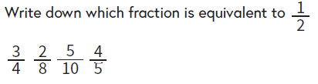 5/10
14. 3 x 6 x 8 = 144
15. 12 ÷ 1000 = 0.012
16. 119 ÷ 7 = 17
17. 2 + 3 = 29/5 = 5 4/5
18. 236 x 5 = 1180
19. Round 2.3 to the nearest whole number 2
20. 14
21. 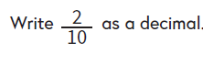 27 ÷ 10 = 2.7
22. 0.2
23. 2.6 x 100 = 260