I am learning to locate a country and describe its features

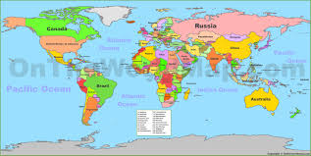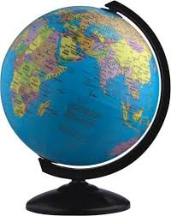

You are to choose a country.

You will then research information about your country.

Once collated, design an information poster for it – you could draw it or use Microsoft Publisher.

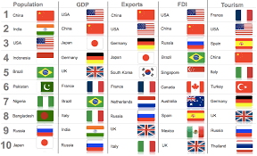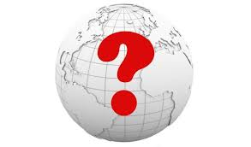

Your report can include the following information:
∙ Flag
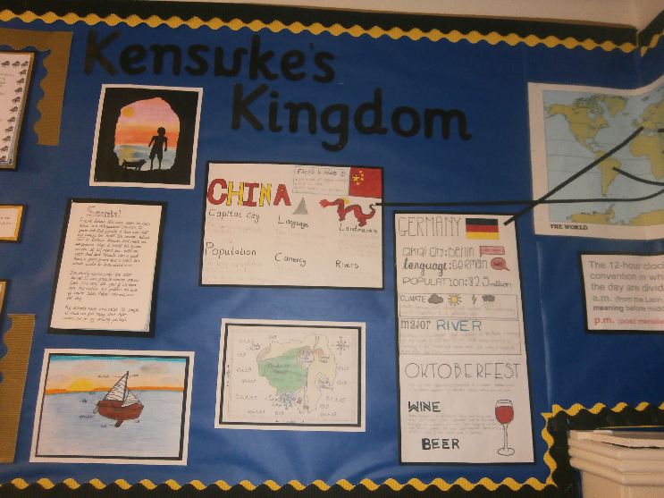
∙ Capital city
∙ Population
∙ Language spoken
∙ Mountains
∙ Rivers
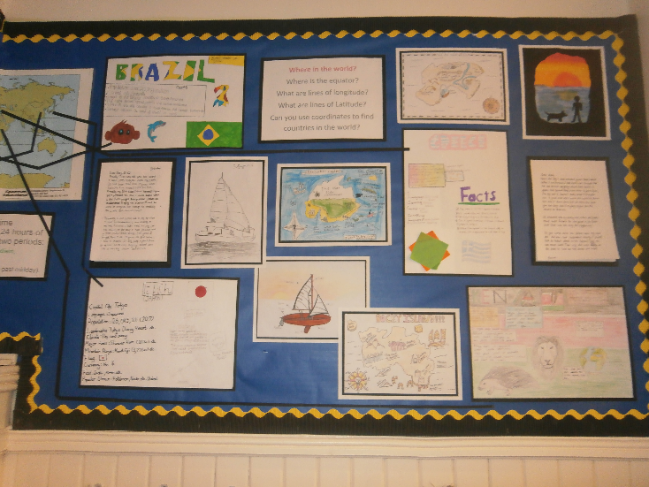
∙ Currency
∙ Famous people
∙ Cuisine
∙ Symbols
∙ Climate

It should take a few hours work.
Below are some WAGOLL (What A Good One Looks Like) from previous children.
