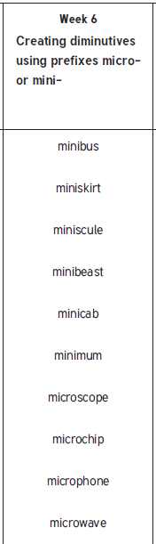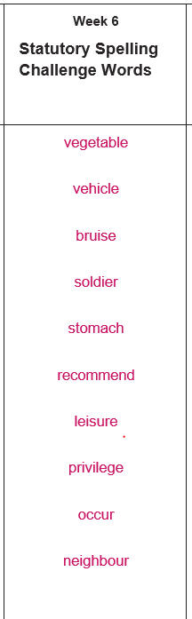

**Year 5 & 6**

**Year 6**