Spring 1: Week 6 w/c 08.02.21
Objectives

- I know the skills and attributes of an effective learner.

INSTRUCTIONS

You will need to be prepared to teach something new to someone.
You may need to use something or the help of someone you have at home.

You will need to make a plan:

1. Who will you teach? Year 5/6
2. Which learning style will you choose to use? (see info about learning styles)
3. How will you teach it?
4. What will you need?
5. How long will it take?
6. How will you record it? (Optional)
7. How will you know you’ve succeeded?

Learning style.
- Teaching someone a skill isn’t as easy as you might think
- On the next slide are a reminder of the examples of learning styles.
- *Think about which one you will be able to use. This lesson is usually done in pairs face to face, but due to Lockdown we are unable to do that.

Use the TASK sheet to help you plan your teaching.

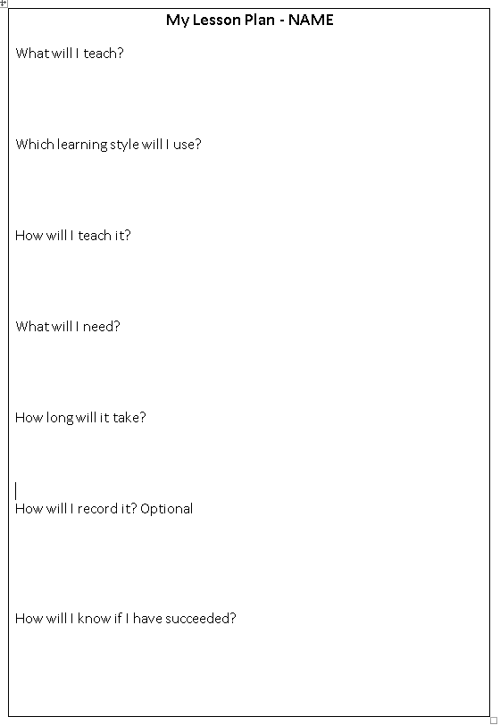

Outcomes
A plan to teach a new skill to someone considering a learning style.
A possible recording of you teaching someone new.

Notes

Powerpoint Lesson 5
TASK Sheet 5

