Day 4 Writing – w/c 22.02.21
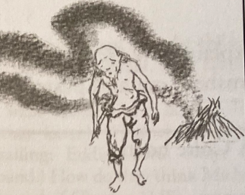
A portrait
Draw and label a picture of Kensuke.

Describe Kensuke’s appearance and clothes.

Write down some things that Kensuke does, and what they tell us about his character.
Action | What does it tell us

Write down some emotions that Kensuke shows in the story and explain the reasons behind them.
Emotion | Reason behind it

