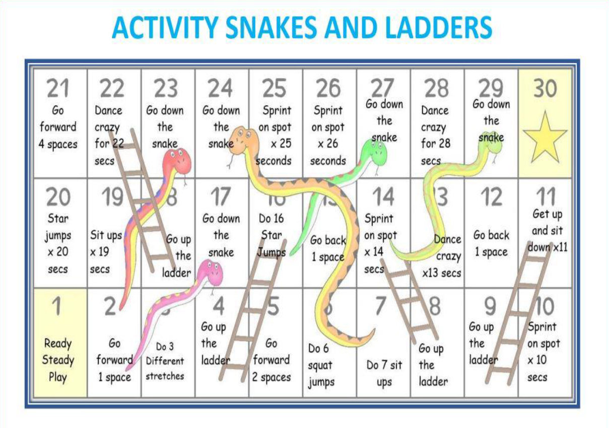

1+ players

**How to play:**

1. Choose a colour counter and place it on tile 1
2. Roll a dice (or this online dice <https://www.online-stopwatch.com/chance-games/roll-a-dice/> )
3. The number you roll is how many spaces you must move

Have fun!