Electricity - Week 1 (w/c 22.02.21)
Choose one of the following scientists who are linked to electricity and research information about them.
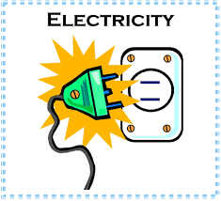
You could even write a biography.
What can you find out?
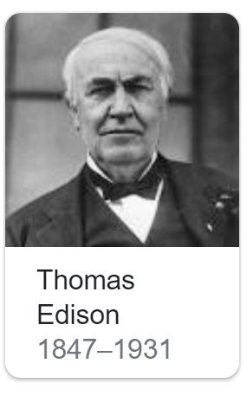
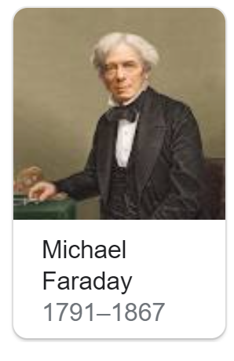
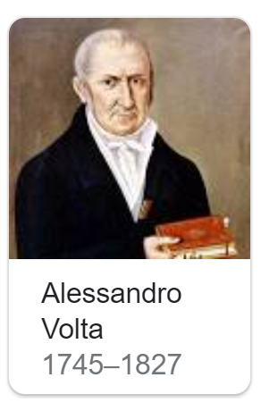
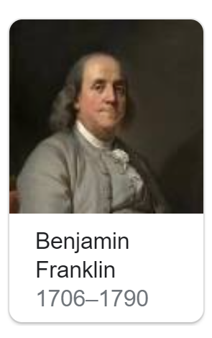
Some Questions to consider:
Why are they famous?
How are they linked to electricity?
When did they live?
What amazing facts can you find out.

