IALT practical problems involving time (converting between units of time)

IALT tell the time

We are going to work out problems like the following one:
Work out a flight time from knowing the take-off time in one time zone to landing time in another.
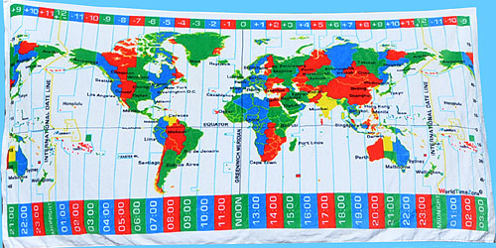

Use the lesson starter, Time Zone map below and this interactive one http://www.timeanddate.com/time/map/
and Time Zone POWERPOINT to help answer the 8 questions.

