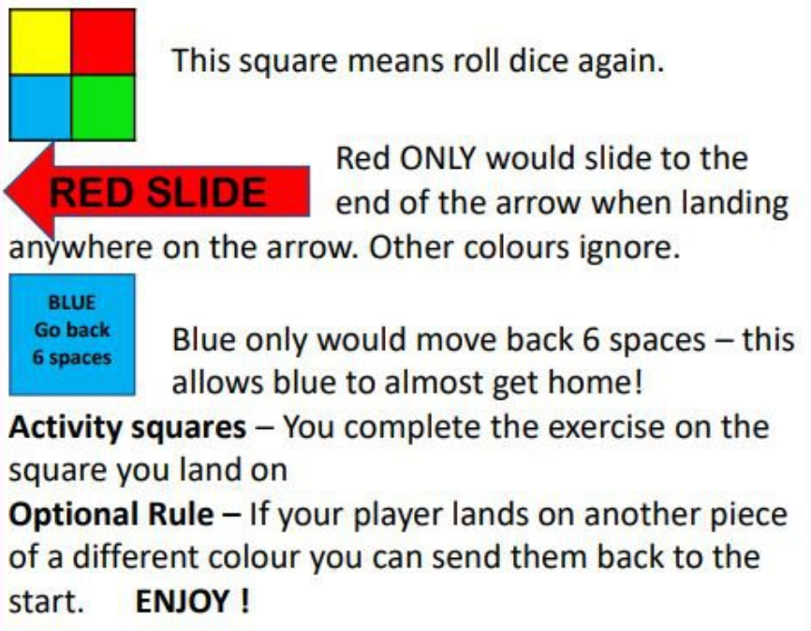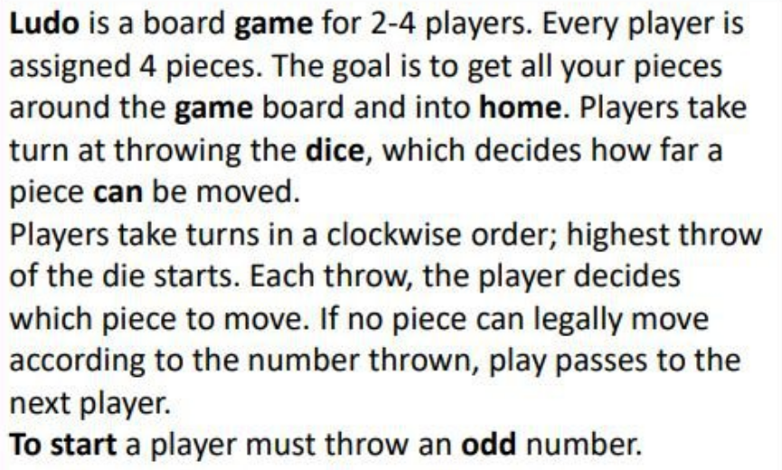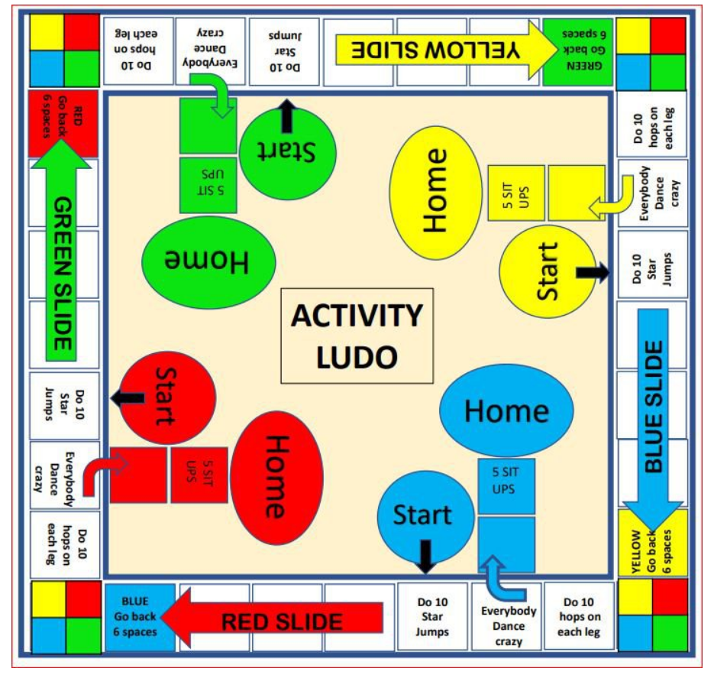

Roll this online dice if you don’t have one at home <https://www.online-stopwatch.com/chance-games/roll-a-dice/>