Dear Springfield Families,

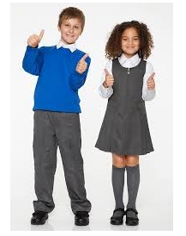
As we are now in the last term of the school year we would like to organise a Uniform Swap Shop. We know uniform can be quite expensive and with the children growing so quickly we thought now would be a good time for families to see if they have any uniform that doesn’t fit their children any more and that they would like to donate to the Springfield Uniform Swap Shop. These pre-loved items can then be passed on to families that may need it. The items that we are looking for donation are:

- Black shoes
- White shirt
- Grey skirt, trousers or dress
- Plain white or black head scarves
- School blue sweat shirt or cardigan (with or without logo)
- Book Bag
All these items should be cleaned and should be in good condition to wear again. These items can then be handed into the school office from Friday 28th^{th} April. The donation collection will close on Friday 26th May. In the Summer 2 term we will then organise a time after school for families to come and have a look around the swap shop.
Thank you for your support,
Laura Crocker
Learning Mentor.

