11th September 2023

SWIMMING LESSONS

Year 4 will start their swimming lessons at Ponds Forge swimming pool, commencing Thursday 14th September 2023.

The children will need appropriate swim wear, i.e. a full costume for girls and swimming trunks/shorts for the boys. Hair must be tied back. No jewellery is allowed. Please remove earrings. A towel will also be needed and a bag to keep it all in.

Children will need to be in school for the normal time of 8.45am. We will leave school at 9.30am. Swimming lessons take place at 10:00am. We will return to school for around 11:15am. Children will be travelling to the swimming baths via coach. Unless hot weather, children will require a warm coat on swimming days.

If your child needs any medication such as an asthma inhaler, they must have it labelled and bring it with them. We must also have an emergency contact number.

………………………………………………………………………………………………………………………………………....................
Year 4 Swimming

Please return to school by Wednesday 13th September 2023

I understand that my child ……………………………………… (name) will be going swimming every Thursday morning from September 14th 2023 onwards.
I will ensure they have the correct swimming kit and a towel each week.

My child will bring an inhaler Yes Not applicable

Emergency Contact Number ….……………….……………

Signed …………………………………………………..

Examples of acceptable swimwear

GIRLS BOYS
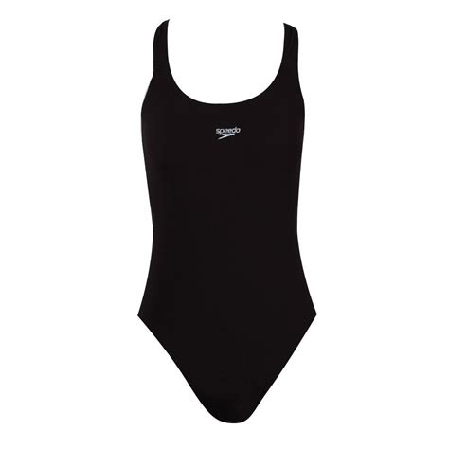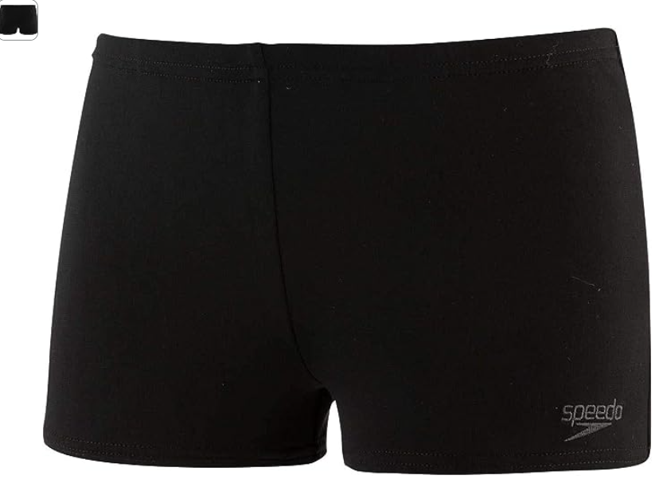
            - Not baggy
            - Must not cover knees

UNISEX
