Thursday 30th November 2023

Y4 Children’s Library Visit

Dear Parents / Carers,

Year 4 will be visiting the Central Children’s Library on Tuesday 19th December.

We will be walking from school to arrive at the library at 10:00am. Children will need to be in school at the normal time, and we will return to school in time for lunch.

Your child needs to wear their school uniform for this trip, including suitable footwear. Please also ensure your child is prepared for the inclement weather with a warm, waterproof coat, gloves and hat.

If your child has a library book to return to the library they can bring it to school either the day before or on the day.

If you have any questions, please do not hesitate to speak to me.

Many thanks,

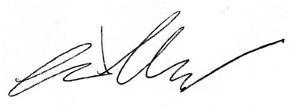

Mr Melleney

