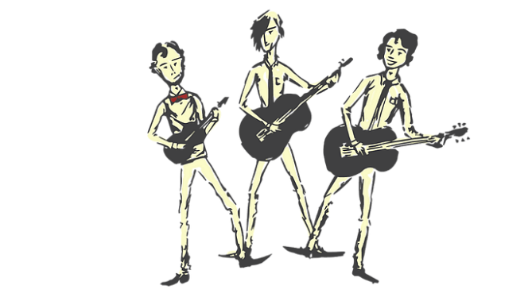

**LEVERS**

A way to lift heavy weights using

the least amount of effort. The longer the lever, the easier it is to lift. The fulcrum is where the lever pivots in order to lift the heavy load.

**Gravity**

Gravity is a force that holds things to Earth’s surface and prevents things from floating off into the atmosphere. It ensures that unsupported objects to fall back down to Earth.

It is said that the famous scientist Isaac Newton was sitting under a tree when an apple fell on his head. He identified it was a force pulling the object down. We now measure gravity in Newtons (N) because of this.

There is gravity on the moon but it is much less than on Earth, so during the moon landings of 1969, astronauts could jump higher for longer due to the weaker pull of gravity.

Forces

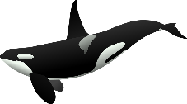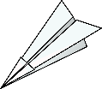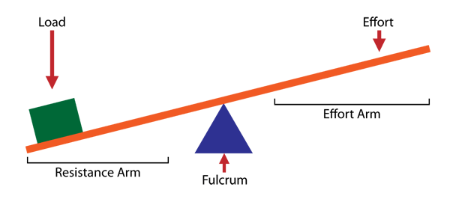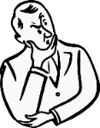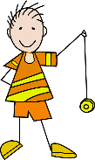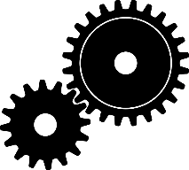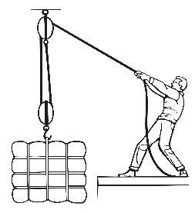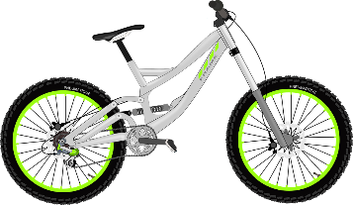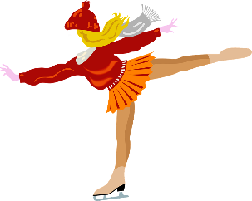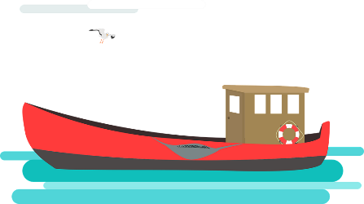

**Friction**

When objects are pushed or pulled, an opposing force can be felt. This opposite force is called ‘friction’. Friction causes things to slow down or stop. The grip on our shoes stops us slipping. Therefore, friction is great. An ice-skate on an ice-rink will move for a long time because there is very little friction. The rougher the surfaces, the greater the friction. This rubbing of two surfaces can release energy, causing heat. (Try rubbing your hands together!)

**GEARS** - Used to transmit power from one part of a machine to another. Connected gears can increase speed, increase force or cause a change in direction. When joined (in mesh) the direction of rotation of the driven gear is the opposite of the drive gear.

**PULLEYS**

Used like levers to lift loads with less effort but for longer distances. Rope is passed through a pulley which is attached to an anchor point and returned back to the ground to be pulled.

**Air Resistance**

Air resistance (sometimes referred to as drag) acts against gravity on falling or moving objects. It’s what you feel on your hair when riding fast on a bike or it’s what fills a parachute to help slow you down when falling from the sky. Object such as aeroplanes reduce air resistance because of their streamlined shape.

**Water Resistance**

Water resistance is a type of *friction* which can slow things down in the water. Water acts upon objects making them harder to pass through. A fish has a *streamlined* body shape to help it swim through water more easily. *Upthrust* is the name of the force which keeps things afloat in water. When gravity is greater than upthrust, the object sinks. When the two are the same, the object floats.